Tileset Settings

**Role of Data**

Tilesets are the collection of "Tiles" used to design your map. Create tiles by setting whether a character can walk on the image used for the tile, and also the behavior in the game.  
  
Original images created for the map can be used as well by creating tilesets which use those images, and assign as map data.  
  
Moreover, whether or not vehicles (boats/large ships) can go over tiles is determined by the position over the tileset. For more information, please view [Asset Standards](https://rmmv.neocities.org/page/01_11_01.html).  
Planes are able to travel over all tiles. However, there are only able to land on tiles which can be walked on.

**Parameter Details**

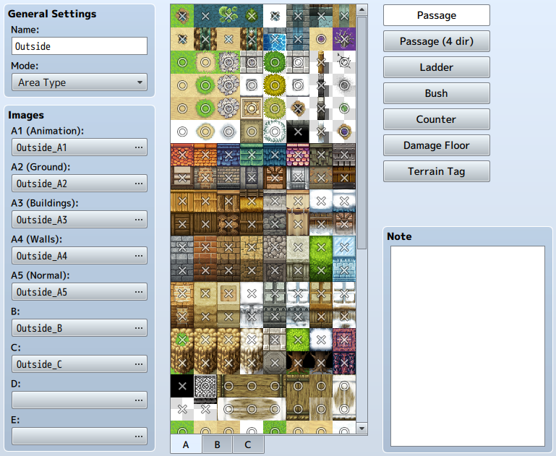

**General Settings**

**Name**

A tileset's name. This property is just used in the editor (does not affect the game).

**Mode**

The purpose of the tileset. This primarily influences the treatment of [special specifications of lower tiles](https://rmmv.neocities.org/page/01_07_01.html#p01) and [battlebacks](https://rmmv.neocities.org/page/01_07_03.html" \l "p01).  
Basically, choose [Field Type] for tiles which represent the overworld like the ocean and land, and [Area Type] for all other situations.

**Images**

Settings for images used for tiles. Specify the file you want to use for each type (Sets A through E) in the [Select an Image] window that is displayed when you press the button for each type. An image's contents will be displayed in the [Tile List] on the right.

**Tile List**

The image used for a tileset in [Images] will be displayed. You can switch the images displayed by clicking tabs [A] through [E] at the bottom. The tiles for the images specified in [A1] through [A5] in the [Images] section will be displayed in order.  
  
Marks representing the parameter values in the current settings editing mode will be displayed on top of each tile. You can change these parameter values by clicking the tile.

**Passage**

Switch to the editing mode where you can set whether a tile can be entered or not. Tiles marked with a [○] can be entered, ones marked with an [×] cannot be entered. Those which have a [☆] can also be entered, however this is for when hiding characters behind buildings (only possible in all other tabs except [A]).

**Passage (4 dir)**

Switch to the editing mode where you can set the direction from where tile can be entered. Use [Passage: Block] when creating tiles that can be passed only from a defined direction. For example, when you set the edge of a tile that represents a cliff as impassable, characters will be unable to move between that tile and the next tile, creating the sense of height.  
  
Those tiles with marks displayed as arrows pointing in a specific indicate that it is possible to move from that direction, ones without arrows are not passable. Moreover, by changing the parameters of the [Passage] setting, these settings will change automatically.

**Ladder**

Switch to the editing mode for ladder settings. When you add this parameter, the direction a character using this tile faces will be fixed to up, giving the appearance of going up and down things like ladders and ropes.  
  
Click the marks in the Tile List to change tiles to have this parameter or not. A mark (a ladder) will be displayed on tiles which have this setting.

**Bush**

Switch to the editing mode for bush settings. When a tile has this setting, 12 pixels from the bottom of characters who cross this tile will appear half transparent, as if their feet are being hidden by dense grass.  
  
However, part of the tile will not become half transparent depending on the image when giving this setting to tiles in [A1] through [A4].  
  
Click the marks in the Tile List to change tiles to have this parameter or not. A mark (two wavy lines) will be displayed on tiles which have this setting.

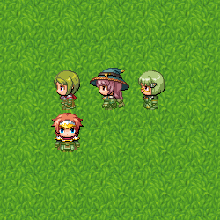

**Counter**

Switch to the editing mode for counter settings. When a tile is given this setting, it will start events even when a character and event are not right next to each other, just as when talking to a character with a desk between them.  
  
Also, setting this to the tile in [A2], tiles having this element will be drawn 12 pixels downward.  
  
Click the marks in the Tile List to change tiles to have this parameter or not. Tiles which have this setting have a mark (4-sided diamond) displayed on them.

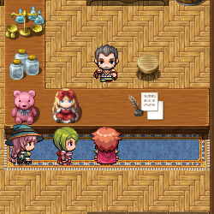

**Damage Floor**

Switch to the editing mode for Damage Floors. When a tile is given this setting, characters will receive damage when crossing this tile. This can be used for representing dangerous terrain like poisonous swamps, trees with thorns.  
  
Click the marks in the Tile List to change tiles to have this parameter or not. A mark (two triangles) will be displayed on tiles which have this setting.

**Terrain Tag**

You can assign values between 0 and 7 to each tile. No specific uses are defined. This value can be retrieved by using the [Get Location Info] event command. Those terrain tags retrieved which are located in upper layers other than zero will be prioritized.

**Note**

The [Note] section can be used to make notes while making your game.

Common Event Settings**Role of Data**

Common events are those events that can be run when you want them to be during gameplay. You can define triggers that you run generally for the overall game such as regularly monitoring play conditions and run some kinds of processes when things such as items and skills are used. Common events created can be run by using event command or triggering it through defined switches.

**Parameter Details**

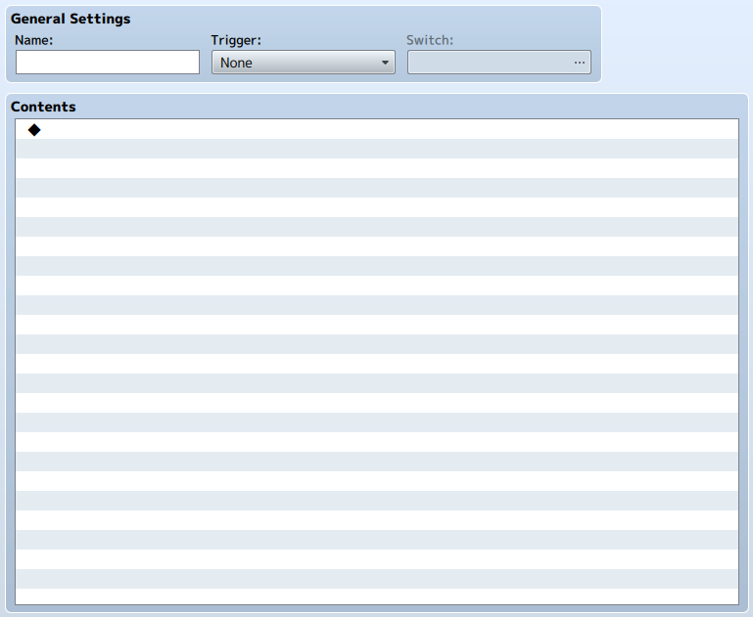

**General Settings**

**Name**

Name of the common event. This property is just used in the editor (does not affect the game).

**Trigger**

Timing for when these events are run will be specified using the following. Moreover, [Autorun] and [Parallel] can only be enabled when the Map Screen is displayed.

**None**

Will only be triggered by skills, items, and other explicitly stated events.

**Autorun**

Will run when the specified [Switch] is switched to ON.

**Parallel**

Will run when the specified [Switch] is set to ON, and will repeat periodically.

**Switch**

Specify what the switch is that triggers the event when setting the trigger to [Autorun] or [Parallel]. If there are multiple common events with the same switch, the event with the youngest ID (at the top of the list) will be run.

**Contents**

Events run using common events will be set based on event commands. Editing is done the same way as the [[Contents](https://rmmv.neocities.org/page/01_09_03.html#p03)] for map events.

**Word of Caution When Using Autorun and Parallel Triggers**

Events which are set to [Autorun] or [Parallel] will have their contents run repeatedly while the [Switch] is set to [ON].  
  
Measures need to be taken to have the [OFF] value which is used as the condition set in order to stop the event from repeating. If you do not control this, there is a possibility that players will no longer be able to control the game depending on the contents of the event.  
  
If you are no longer able to play while in Playtest, you can forcibly close the game by pressing the [X] button or by hitting [Alt] + [F4].

System Settings

**Role of Data**

System data is the collection of things such as the initial settings for the game. You can specify things such as the formation and positions of party members at the start of the game, and the music that places in various situations during gameplay.

**Parameter Details**

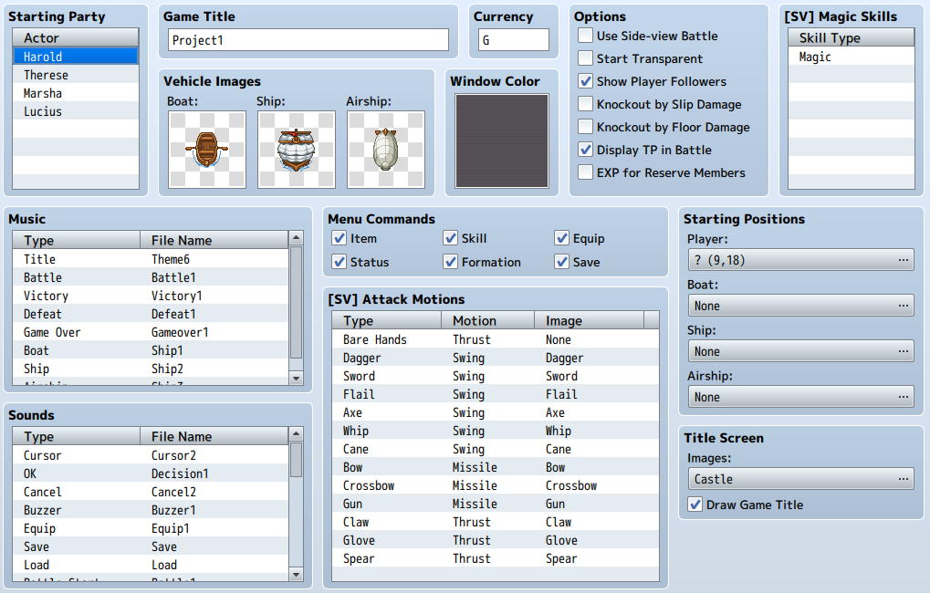

**Starting Party**

The members that form the party at the start of the game.  
  
There is no limit to how many actors you can place into a party, however only the first 4 can participate in battle.  
  
To change or add new actors, double-click items (a blank row when adding) in the list, and specify the new actors. To remove actors, right-click the one you wish to remove and select [Delete] in the menu that is displayed.

**Game Title**

The name of your game. This will be set when you enter the name into the [Game Title] field when creating a new project. This name will be displayed in the Game Screen title and the window's title bar.

**Vehicle Images**

Images for the vehicles (boats/ships/planes) displayed on the map. You can select an image in the [Select an Image] window that appears after double-clicking on each vehicle's section. Select [(None)] if you do not want to display an image.

**Currency**

The name for the unit of money used in the game. This is used for things such as displaying how much gold the player has in the Menu Screen.

**Window Color**

Background color of the windows used in the game. This is specified using the composition of the [Red], [Green] and [Blue] values (-255 to 255) in the window that appears when you double-click inside the field.

**Options**

Specify special processes and rules related to the game's behavior.

**Use Side-view Battle**

Displays the Battle Screen in a side point of view. Front-view Mode will be used if this is not checked.

**Start Transparent**

When enabled, the game will start with the character transparent (hidden). Use the [Change Transparency] event command to switch this off.

**Show Player Followers**

When enabled, the game will start with actors, starting from the 2nd, following the main actor while moving on the map. Only 4 actors starting from the first will be displayed even when there are 5 members in a party.

**Knockout by Slip Damage**

When enabled, this allows the HP to reach 0 by when damaged by states such as "Poison". HP will only go down to 1 when this is disabled.

**Knockout by Floor Damage**

When enabled, this allows the HP to reach 0 when damaged by tiles (Damage Floors) on the map. HP will only go down to 1 when this is disabled.

**Display TP in Battle**

When enabled, TP values will be displayed in the party members' Status Window in the Battle Screen.

**EXP for Reserve Members**

When enabled, actors who did not participate in battle will also receive EXP when a battle is won.

**Music**

Music that plays while playing. Specify the BGM or ME that plays in the parameters for each scene. The parameters for each scene are as follows. Also, the music that plays when the player moves on the map will be set in the map data.

|  |  |
| --- | --- |
| Title | The BGM that plays in the Title Screen. |
| Battle | The BGM that plays in the Battle Screen. |
| Victory | The ME that plays after battle when a party wins. |
| Defeat | The ME that plays after battle when a party loses. |
| Game Over | The ME that plays in the Game Over screen. |
| Boat | The BGM that plays when on a boat. |
| Ship | The BGM that plays when on a ship. |
| Airship | The BGM that plays when on a airship. |

**Sounds**

The sound effects (SE) that play in situations such as when the player moves or performs an action during battle. Set the SE file that will play for each situation. The parameters for each situation are as follows.

|  |  |
| --- | --- |
| Cursor | When moving the cursor. |
| OK | When confirming the command to use. |
| Cancel | When canceling a command in the Menu Screen, etc. |
| Buzzer | When selecting a command that cannot be used in the Menu Screen, etc. |
| Equip | When changing equipment in the Menu Screen. |
| Save | When saving the game. |
| Load | When loading the game. |
| Battle Start | When encountering an enemy. |
| Escape | When a party or enemy escapes during battle. |
| Enemy Attack | When an enemy performs a normal attack during battle. |
| Enemy Damage | When damaging an enemy during battle. |
| Enemy Collapse | When an enemy is knocked out during battle. |
| Boss Collapse 1 | When the [Collapse Effect] of a [Trait] knocks out an enemy [Boss]. |
| Boss Collapse 2 | When the [Collapse Effect] of a [Trait] displays the vanishing effect of an enemy [Boss]. |
| Actor Damage | When an actor is damaged. |
| Actor Collapse | When an actor becomes knocked out during battle. |
| Recovery | When an actor or enemy recovers during battle. |
| Miss | When a character fails to land a physical attack. |
| Evasion | When a character evades a physical attack. |
| Magic Evasion | When a character evades a magic attack. |
| Magic Reflection | When a character reflects a magic attack. |
| Shop | When buying or selling an item in the Shop Screen. |
| Use Item | When an item is used in the Menu Screen. |
| Use Skill | When a skill is used in the Menu Screen. |

**Menu Commands**

Switch commands in the Menu Screen to ON or OFF.

**[SV] Attack Motions**

Select motions that are displayed for normal attacks in side-view mode.

**[SV] Magic Skills**

List of skill types which require chanting motions in side-view mode.

**Starting Positions**

The positions of the player and vehicles (boats/ships/planes) when the game starts. Open the Settings Window for each field by pressing its [...] button, and specify the location by clicking a point on the map on the right.  
  
The starting location specified will be shown using an icon in a blue frame on the map. This icon can be moved just like map events by dragging them, and you can delete them by pressing the [Delete] key.  
  
However, if the starting position for the player is undecided (deleting the icon), you cannot start the game.

**Title Screen**

The image which is displayed first in the Play Screen after starting the game. You can select an image in the [Select an Image] window that appears by pressing the field's [...] button. When [Draw Game Title] is enabled, the game's name that was specified in [Game Title] will be displayed towards the top of the Title Screen (disable when including the title of the game in the image).

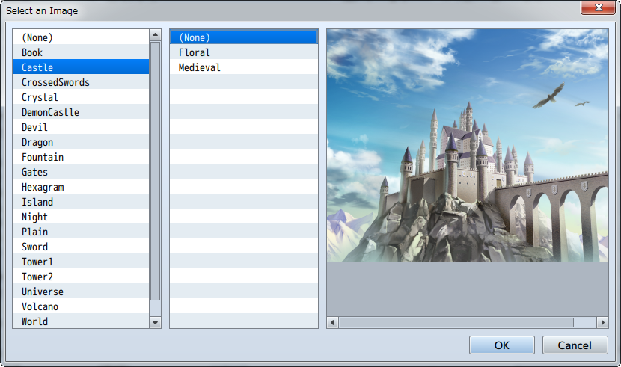

Type Settings

**Role of Data**

Types are the collection of name parameters of game elements, skill types, weapon types, armor types, and equipment types. The types configured here will be reflected in the Type section for each settings window.

**Parameter Details**

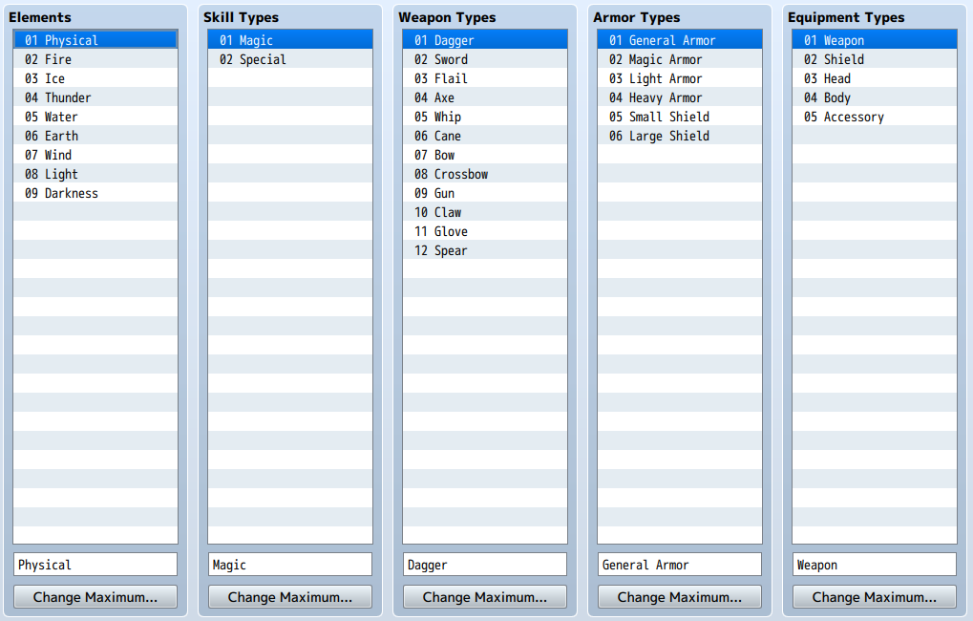

**Elements**

List of element names. Click the name you want to change in the list, and enter the name in the field at the bottom. To increase and decrease the amount of names, click the [Change Maximum] button, and specify the new amount.  
  
This name will be used whenever making a selection in the editor. Changing the specific details of elements is done using skill and weapon data.

**Skill Types**

A list of the names of types that you specify in the [Skill Types] section. The method for changing names is the same as the [Elements] section.

**Weapon Types**

A list of the names of types that you specify in the [Weapon Types] section. The method for changing names is the same as the [Elements] section.

**Armor Types**

A list of the names of types that you specify in the [Armor Types] section. The method for changing names is the same as the [Elements] section.

**Equipment Types**

A list of the names of types that you specify in the [Equipment Types] section. The method for changing names is the same as the [Elements] section.

Terms Settings

**Role of Data**

Terms are the collection of the names of things such as game commands and parameters. By changing the standard names to fit your game's world, you can create an even more original game.  
  
You can enter characters in the space provided in each settings field. However, the entire name may not be displayed if it is too long.

**Parameter Details**

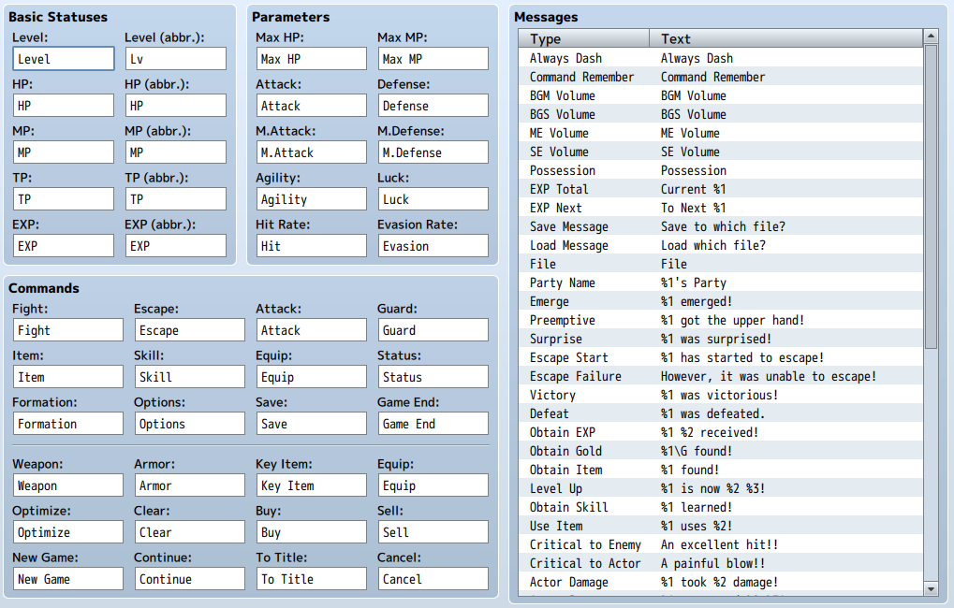

**Basic Statuses**

Terms for Level, HP, MP, TP as well as EXP. Specify the words used in the parameter provided for each default name. Those parameters with [(abbr.)] are where you can specify a shortened version to be displayed in places such as the status window in the Battle screen.

**Parameters**

Names of parameters. Specify the words used in the parameter provided for each default name.

**Equipment Types**

Names for the items which a player wears. Specify the words used in the parameter provided for each default name.

**Commands**

The names of commands and choices displayed in places like the game's Menu Screen. Specify the words used in the parameter provided for each default name.

**Messages**

Contents of the messages displayed during gameplay. Specify the sentences used in the parameter provided for each default name. [%1] and [%2] and so on will be replaced when the message is run.

How to Set Traits

**Settings Overview**

The [Traits] parameter for actors, classes, weapons, armors, enemies and states define the unique properties and functions for each type of data.  
  
The 24 types of properties that can be given are found below. By giving these properties according to the contents of the data you wish to create, you can give the various types of data complex traits.  
  
Traits for classes, weapons, armors and states will be reflected in a character's traits when that character has that type of data added (equipped).  
  
Furthermore, please be careful when configuring traits that permanently restrict actions. For example, a weapon which is set to [Lock Equip] cannot be removed once an actor equips it.

**Setting Traits**

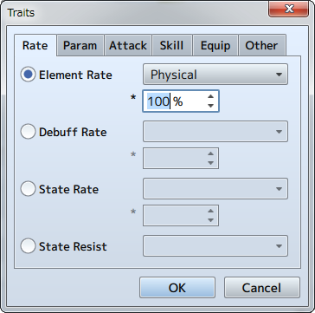

To set a trait, double-click an empty row in the Traits field. Select the property type in the displayed window, and specify what effects are applied.  
  
The property details will be displayed in the [Traits] list. You can re-edit the contents of properties by double-clicking the item. Additionally, you can perform actions such as copying the settings and deleting them in the context menu that is displayed when you right-click a trait.

**Contents of Each Trait**

**[Rate] Tab**

**Element Rate**

Change the damage received when an attack contains an element. Specify the desired element and its rate (0 to 1000%). An attack's damage will become larger than normal if the rate is set over 100%, indicating that this character is weak against the specified element.

**Debuff Rate**

Change the success rate of items and skills which have a [Debuff] effect when used. Specify the desired parameter and the change of success (0 to 1000%, 100% means no change).

**State Rate**

Change the success rate of items and skills which have an [Add State] effect when used. Specify the desired state and the change in rate of success (0 to 1000%, 100% means no change).

**State Resist**

Negates the specified state. If [Knockout] is selected, a character will not be knocked out even when their HP reaches 0.

**[Param] Tab**

**Parameter**

Raises and lowers parameters such as Max HP, and Attack Power at a fixed rate. Specify the desired parameter and the change (0 to 1000%, 100% means no change).

**Ex-Parameter**

Raises and lowers the values of extra parameters such as Hit Rate and Evasion Rate. Specify the desired parameter and the percentage to add (-100 to 100%, starting value is 0%).

**Sp-Parameter**

Raises and lowers the values of special parameters such as Target Rate and Guard Rate. Specify the desired parameter and the change (0 to 1000%, starting value is 100%).

**[Attack] Tab**

**Attack Element**

Adds the specified element to normal attacks.

**Attack State**

Adds an effect of changing states to normal attacks. Specify the effect and the change in rate of success (0 to 1000%, 100% means no change).

**Attack Speed**

Raises and lowers agility when choosing a normal attack in battle. Specify the raise/lower value (-999 to 999).

**Attack Times**

Increases the number of times (1 time normally) a target is damaged using normal attacks. Specify the amount to increase.

**[Skill] Tab**

**Add Skill Type**

Allows the player to select the specified skill type command.

**Seal Skill Type**

Prevents the player from selecting the specified skill type.

**Add Skill**

Makes the specified skill usable.

**Seal Skill**

Makes the specified skill unusable.

**[Equip] Tab**

**Equip Weapon**

Makes the specified weapon type able to be equipped.

**Equip Armor**

Makes the specified armor type able to be equipped.

**Lock Equip**

Makes it so that equipment for the specified slot cannot be changed. Use this when you do not want to change the equipment of an actor that is temporarily in the party.

**Seal Equip**

Prevents equipment from being equipped in the specified slot. This allows you to create things such as "Two-handed Weapons" which seals shield equipment and "Full-body Clothing" that seals head equipment.

**Slot Type**

This can be only set to [Dual Wield]. In exchange for not being able to equip a shield, characters can equip two weapons.

**[Other] Tab**

**Action Times +**

Sets the chance of raising the number of actions during battle by 1 using the specified probability. If a character has multiple entries for this trait, each instance will be calculated separately on whether to increase the number of actions using the specified probability. For example, if a character has two of these traits with a probability of 50% each, the chance of the number of actions increasing 2 times, and the chance of actions not increasing even 1 time will both be 25% (50% x 50%).

**Special Flag**

Grants special traits related to actions during battle.

|  |  |
| --- | --- |
| Auto Battle | Characters will perform actions automatically without taking commands from the player. |
| Guard | Decreases the amount of damage taken by a fixed rate. |
| Substitute | Take damage in place of an ally when they are attacked when their HP is low. |
| Preserve TP | Accumulated TP will be preserved for the next battle. By default, TP will be reset each battle, and the amount of TP that each character has at the start of battle will be decided randomly. |

**Collapse Effect**

This only effective towards enemies. The effect when an enemy is knocked out and collapses will change to the specified effect.

**Party Ability**

Grants special traits related to the party's actions during battle. The various traits of each actor will be reflected as traits for the entire party when even just one of those actors is in the party.

|  |  |
| --- | --- |
| Encounter Half | The frequency of encounters while moving on the map will be reduced by half. |
| Encounter None | No encounters will occur while moving on the map. |
| Cancel Surprise | Suprise attacks (when only an enemy troop can perform actions on the first turn) will no longer occur when a battle starts. |
| Raise Preemptive | The chance of preemptive attacks (when only the party can perform actions on the first turn) when a battle starts will increase. |
| Gold Double | The amount of gold received when the party wins a battle will be twice the normal amount. |
| Drop Item Double | The rate of a party getting items from enemies after winning a battle will be twice the normal rate (only when an item has been configured for the enemy that is defeated). |

How to Set Effects

**Settings Overview**

The [Effects] parameter defines the effects that you give to the desired character when an actor/enemy uses a skill or item.  
  
The 13 types of effects that can be given are found below. You can create skills/items which possess a combination of effects by configuring multiple effects.

**Setting Effects**

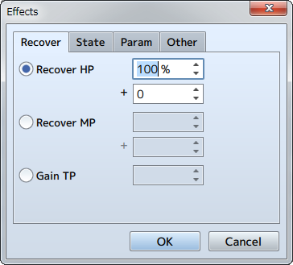

To set an effect, double-click an empty row in the Effects field. Select the type of effect in the window that is displayed, and specify such things as the targets which the effect applies to, the strength of the effect, etc.  
  
The details of the configured effect will be displayed in the [Effects] list. You can re-edit the contents of effects by double-clicking the item. Additionally, you can perform actions such as copying the settings and deleting them in the context menu that is displayed when you right-click an effect.

**Contents of Each Effect**

**Recover Tab**

**Recover HP**

Recovers HP (adds to current value). Specify a value that is a percentage of the target character's Max HP (-100% to 100%) and a set value (-999999 to 999999). In the case that you want to set just one of the values, set the other value to 0. Setting this effect to an item, the recovery value will change according to the user's [Pharmacology] special trait value.

**Recover MP**

Recovers MP (adds to current value). Specify a value that is a percentage of the target character's Max MP (-100% to 100%) and a set value (-9999 to 9999). In the case that you want to set just one of the values, set the other value to 0.

**Gain TP**

Increases TP by only the specified amount. Specify the increase using a set value (0 to 100).

**[State] Tab**

**Add State**

Adds a state. Specify the desired state and the change in rate of success (0 to 1000%). By setting this to a value higher than 100%, this will have a higher chance of success to add the state than its original effectiveness.

**Remove State**

Removes a state. Specify the desired state and the change in rate of success (0 to 100%).

**[Param] Tab**

**Add Buff**

Raises the fluctuation level of the specified trait by one. For each level, there is a 25% fluctuation in the original value. To have this raise more than two levels at one time, add this effect multiple times. Set the target trait and the number of turns (1 to 1000) this effect will last.

**Add Debuff**

Lowers the fluctuation level of the specified trait by one. For each level, there is a 25% fluctuation in the original value. To have this lower more than two levels at one time, add this effect multiple times. Set the target trait and the number of turns (1 to 1000) this effect will last.

**Remove Buff**

Resets a trait to its original value when the fluctuation level of the specified trait is buffed.

**Remove Debuff**

Resets a trait to its original value when the fluctuation level of the specified trait is debuffed.

**[Other] Tab**

**Special Effect**

You can set this only to [Escape]. The target character will flee from battle. If the actor has received this effect, they will not earn any EXP.

**Grow**

Permanently raise the value of a trait. Specify the target trait and the value (1 to 1000) to be added.

**Learn Skill**

An actor will learn the specified skill. This effect will not be applied to enemies.

**Common Event**

Run the specified common event. Only one of this effect can be set for one type of data.

Events

**What Are Events?**

In RPGs, the game processes through things that happen in the game such as conversations with characters, getting items from treasure chests and fighting with bosses. Using this software, you will prepare those things that occur using data called "Events".  
  
Events are the mechanisms for carrying out some sort of process. For example, when a player talks to a character, you can assign an image and the sentences that appear on the screen for the character that responds by using events.  
  
It is a device which causes different things to happen in the game by running events depending on the play conditions and actions from the player.

**Event Types**

Events consist of the following 3 types. Those events related to the game's story and progression are made using "Map Events".

**Map Events**

Events which are run on the Map Screen. Use this type of event to express things like conversations with characters, and chests from which players can get items. Additionally, you can define events related to the game's structure and progression such as players changing locations and cut scenes through events that don't have images.   
  
To create and edit Map Events, switch to event editing mode by clicking the [Events] button in the toolbar in the Main Window (or by going to [Mode] → [Events] in the menu bar).

**Battle Events**

Events that are run in the Battle Screen. For example, these are used on events such as "Enemy transforms when HP is lower than the defined value". Create and edit these events in the [[Troops](https://rmmv.neocities.org/page/01_08_07.html)] tab in the database.

**Common Events**

Events that are commonly run. Use these to call Map Events and Battle Events, and setting events that occur when using special items. Create and edit these events in the [[Common Events](https://rmmv.neocities.org/page/01_08_11.html)] tab in the database.

Map Event System

**Map Event Processing Flow**

**Expressing Events**

The details of events expressed in the game using map events are defined following this flow: where (location), what kind of situation (appearance conditions), what action is taken (trigger), what happens (contents).  
  
Events such as characters and chests with items in them are expressed by assigning images to the map events which defined the contents of what happens. Also, processes such as moving between the outside and inside of buildings, cut-scenes that advance automatically can be prepared using events that do not have images.  
  
When creating an event, you first need to decide "where (location) and what happens) in the map view of the Main Window. After doing this, you will decide the remaining contents such as "what situation (appearance conditions)".

**Event Pages with "Conditional" Contents**

It is possible to change the details of what happens according to the play conditions of the game using map events.  
  
[Event Pages] are responsible for this. Event pages [conditionally] determine the contents of events. You can have one event with up to 20 event pages, and specify different images, triggers, and what processes are run for each. In other words, you can [conditionally] choose from 20 different events for one map event.

**Restrict Event Pages Using Appearance Conditions**

Deciding "what situation" to use the [conditional] event page is the [Conditions] parameter. Conditions are set based on criterion such as the values of [Switches] and [Variables], or "does the player have the specified item".  
  
Map events occur during gameplay based on the contents of the page which meet these conditions. When there are multiple pages which meet these [Conditions], the event page with the highest number will be used on the map. Conversely, nothing will happen on the map if there are no event pages which meet the [Conditions].

**Evaluating Play Conditions**

**Evaluating Play Conditions Using Switches**

Under [Conditions] in the event page, [Switches] and [Variables] are primarily used for determining the play conditions of the game.  
  
Switches record either the [ON] or [OFF] value. This is used for evaluating conditions of the game and state of progress such as "did the player accept the request from the king" or "did the player defeat the boss".  
  
The game will start with all switches set to [OFF]. On top of that, when running an event that changes the position in the game, the specific switch's value in the "contents" will be switched to "ON".  
  
By using that switch in the [Conditions] of other event pages, it is possible to use the switch being set to [ON] to switch the contents of the map event all at once. The games story can be built through continuously changing the state of the overall game through the changing of these events.

**Variables That Store Values**

[Variables] are what store arbitrary values (integers). The values at the start of the game are set to 0, and you can do calculations such as assigning values of your choice according to the state of the game or add to other values (use [Control Variables] event command).  
  
By using this variable, you can do things like change the details of events using the HP of the player and the amount of gold they possess, allowing you to finely control the map event conditions and results.

**Management Switch Variables**

It is possible to use up to 5000 switches and variables each in one game. Which switch number/variable, what state is evaluated is up to the creator. Use names that help you understand their purposes so that you do not confuse the relationship of the two. You can set their names in the [Name] field in their respective selection windows.

**Using the "Self Switch" for Autonomous Events**

You can also use "Self Switches" in map events. This switch can be used only in each individual map event. You can store values in the 4 types of self switches, "A" through "D", included in an event.  
  
This self switch is used for evaluating the state of events that are completed using self processing. For example, for treasure chests which contain items, by managing whether the chest was opened or not using self switches, and setting the contents for "before opening" and "after opening" in two event pages, you can make it so that an item can be obtained only the first time the chest was checked.

Map Event Creation and Controls

**Map Event Creation and Controls**

**Switch to Editing Mode**

To create and edit Map Events, switch to event editing mode by clicking the [Events] button in the toolbar in the Main Window (or by going to [Mode] → [Events] in the menu bar).

**Creating a New Map Event**

To create a new map event, double-click the location where you wish to place the event on the map view. Edit the settings for your event in the [Event Editor] Window that appears, and click [OK]. For more information on parameter details, please view [[Map Event Settings](https://rmmv.neocities.org/page/01_09_03.html)].

**Re-editing and Moving**

When you place a map event, an icon will be displayed at that location (the image that was selected on the first event page will be used). Double-clicking this icon will open the [Event Editor] Window where you can re-edit the event's settings details. You can change the location by dragging and dropping the icon.

**Controls via the Context Menu**

When you right-click the map view in event editing mode, you can perform actions such as copying and deleting the event that you placed. The functions of each item are as follows.

**Edit ("New" when an event has not yet been placed)**

Opens the Event Editor Window.

**Cut**

Copies the map event that you right clicked to the clipboard and delete it.

**Copy**

Copies the map event that you right clicked to the clipboard.

**Paste**

Places the map event in the clipboard at the location you right-clicked.

**Delete**

Deletes the map event that you right-clicked.

**Quick Event Creation**

Creates 4 types of events using simple settings (mentioned later).

**Set Starting Position**

Sets the position for the player and vehicles at the start of the game. The starting position will be indicated by a blue frame.  
*Event icons use white frames.

**Quick Event Creation Feature**

By going to the [Quick Event Creation] section in the Context Menu, you can create the four following types of events often created in typical RPGs using simple settings: [Transfer], [Door], [Treasure] and [Inn]. The contents and parameter details for events that you can create using each option are as follows.  
  
Just like other events, events created using Quick Event Creation can also have their parameter details edited, copied, etc.

**Transfer**

Creates an invisible (no image) event that transfers the player to the specified location. Use this for things such as entrances and stairs. In [Location] and [Direction], specify the location after transfer and the direction that the player is facing.

**Door**

Creates an event with an image that transfers the player to the specified location. Specify the image used in the [Image] field, and the location after transfer in [Location].

**Treasure**

Create an event where a player can get an item from a treasure chest limited to the first time the treasure chest is checked. Set the image to display in [Image], and specify what the player can obtain (gold/items/weapons/armor) in the [Content] section.

**Inn**

Event which allows the party to complete recover. Set the image to display in [Image], and the price in the [Price] field.

Map Event Settings

**Common Settings and Event Page Controls**

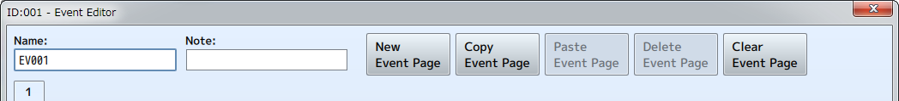

**ID (Displayed in Title Bar)**

The event's unique ID. IDs will be automatically set for each map in the order that they are created. This ID is used for occasions such as specifying events using variables.

**Name**

The name of the map event. This property is just used in the editor (does not affect the game). The name that uses the ID will be automatically entered in the initial state. Change the name of the event to something easily identifiable if necessary.

**Note**

A text area where you can freely enter notes.

**Event Page ID**

The event page ID included in the event. By clicking a tab, you can switch to the event page that you want to edit.

**Event Page Control Buttons**

The buttons located towards the top of the window can be used to perform actions such as creating new event pages and deleting them. The functions of each button are as follows.

**New Event Page**

Creates a new consecutively numbered event page following the one that is currently being edited. Each following additional event page will have an ID that increases by 1 each time one is created.

**Copy Event Page**

Copies the contents of the event page currently being edited to the clipboard.

**Paste Event Page**

Adds (inserts) the event page in the clipboard using the ID that follows the event page currently being edited. Each event page added will have an ID that increases by 1 each time it is created.

**Delete Event Page**

Deletes the event page that is currently being edited. The ID for each event page that follows the one that was deleted will have its ID decreased by 1.

**Clear Event Page**

Deletes the entire contents of the event page currently being edited (returns it to its initial state).

**Event Page Settings**

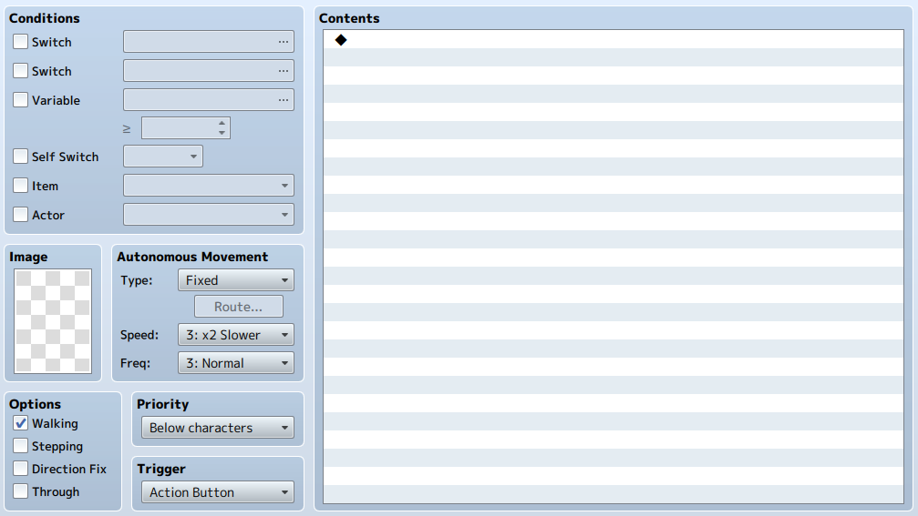

**Conditions**

Conditions for the map event to appear on the map based on the settings of this event page. Enable what will be used as the conditions within the [Switch], [Variable], [Self Switch], [Item] and [Actor] settings, and set the criterion to be evaluated.  
  
Leave the condition settings as disabled when you want to have an event occur without any conditions. If multiple conditions are set, an event will only occur when all conditions are met.  
  
If the conditions of multiple event pages are met, the event with the ID with the highest value will be used. Conversely, an event will not occur if there are no pages which meet the conditions set.

**Switch**

The event will occur when the specified switch is set to ON.

**Variable**

The event will occur when the specified variable is greater than the fixed value.

**Self Switch**

The event will occur when the specified self switch is set to ON.

**Item**

The event will occur when a party possesses the specified item.

**Actor**

The event will occur when the specified actor is in the party.

**Image**

Images that are displayed when an event occurs on a map. To specify an image, click the file list (left) and image (right) in order in the [Select an Image] window that appears when you double-click inside the frame.  
  
An image will not be visible on a map if an image is not set. Select [(None)] located in the very top of the file list in the [Select an Image] window to delete the image you have set.

**Autonomous Movement**

Specifies how the map event will move based on the [Type], [Speed] and [Frequency] settings. [Speed] determines the speed when the map event moves and the greater the number, the faster the map event will move. [Frequency] is the interval at which the map event moves and the greater the number, the shorter the movement interval will be. You can choose from the following 4 types of movements in [Type].

**Fixed**

The map event will not move.

**Random**

The map event will move around at random.

**Approach**

The map event moves towards the location of the player.

**Custom**

The map event follows the specified route. You can specify the route in the window that appears when you click [Set Movement Route]. For more information, please refer to [[Set Movement Route](https://rmmv.neocities.org/page/01_10_06_01.html)].

**Options**

How the image will be displayed. Enable the items to apply as necessary.

**Walking**

Displays animation when moving. Use when wanting to display characters and animals as walking.

**Stepping**

Displays the stepping animation while the character is stopped. Use when wanting to display the water's surface and fire as moving.

**Direction Fix**

Prevents the direction that the image is facing from changing while moving.

**Through**

Allows to pass through terrain and events that cannot be passed through.

**Priority**

Choose from the below in order to specify the priority of how players and other events are displayed on top of one another. The image that is on top will be prioritized and displayed when events and players can overlap.

**Below characters**

Players and so on will be able to move on top of this event. However, if a tile is selected in [Images], whether or not the player can move on top of that tile depends on the settings of the tile.

**Same as characters**

Will be at the same height as characters, and it will not be possible to go through this event.

**Above characters**

Players and so on will be able to move beneath this event.

**Triggers**

Choose the timing for when the processing of the [Contents] of an event that occurs on the map will be.

**Action Button**

When the player touches the event, and presses the action button while facing (when overlapping an event where overlapping is possible) in the direction of the event.

**Player Touch**

When the player touches the event (when overlapping an event where overlapping is possible), and presses the action button while in that state.

**Event Touch**

When an event makes contact (when overlapping where overlapping is possible) with a player through via the autonomous movement of the event as well as when in the same state as in [Player Touch].

**Autorun**

When the event appears after meeting appear conditions.

**Parallel**

When the event appears after meeting appear conditions (contents of the event will be repeatedly processed).

**Contents**

List of the processes that will be run when the [Trigger] is activated. For more information, please refer to the following [Editing Contents] section.

**Editing Contents**

**Viewing the Contents of the List**

Processes added to the game while playing are edited using commands called [Event Commands].  
  
Event commands will be processed in order from the top item in the list and will be reflected in the game being played. Rows with a [◆] in the list indicate a registered event command. Rows with a [:] display the settings of event commands and indicate the position of where the flow of processes will be branched.

**Additional Event Commands**

Double-click the row with a [◆] to add an event command to the list. Select the event command to use in the window that appears, and define the details (excluding some parts) of the process. Double-clicking a row which already has an event command will insert the new event command in that position.

**Controls via the Context Menu**

Registered event commands will be displayed using a [◆]. Right-clicking this row will cause a menu to appear where you can perform actions such as [Copy] and [Delete]. Each available action is as follows.

**New**

Inserts a new event command at the selected position.

**Edit**

Re-edit the settings of the event command in the row that is selected.

**Cut**

Copies the contents of the selected row to the clipboard and deletes it from the list.

**Copy**

Copies the contents of the selected row to the clipboard.

**Paste**

Inserts the contents of the clipboard to the row that is selected.

**Delete**

Delete the event command in the row that is selected.

**Select All**

Selects everything in the list as items to be edited.

**Test**

Tests the selected event in the game screen.

**Selecting Multiple Items at Once**

While having one of the rows in the list selected, clicking another row while holding down the [Shift] key will select all the event commands (blocks that have a [◆]) within that range. Right-clicking those items selected (highlighted in blue) will allow you to perform actions to all the items via a context menu. However, you can only select the items which are in the same branch when including branch processes.

Event Commands

The following event commands that can be used in [Contents] in events are as follows. Make good use of these to produce your game's story.

**Tab 1**

**▼Message**

* [Show Text](https://rmmv.neocities.org/page/01_10_01.html#p01)

* [Show Choices](https://rmmv.neocities.org/page/01_10_01.html#p02)

* [Input Number](https://rmmv.neocities.org/page/01_10_01.html#p03)

* [Select Item](https://rmmv.neocities.org/page/01_10_01.html#p04)

* [Show Scrolling Text](https://rmmv.neocities.org/page/01_10_01.html#p05)

**▼Game Progression**

* [Control Switches](https://rmmv.neocities.org/page/01_10_02.html#p01)

* [Control Variables](https://rmmv.neocities.org/page/01_10_02.html#p02)

* [Control Self Switch](https://rmmv.neocities.org/page/01_10_02.html#p03)

* [Control Timer](https://rmmv.neocities.org/page/01_10_02.html#p04)

**▼Flow Control**

* [Conditional Branch](https://rmmv.neocities.org/page/01_10_03.html#p01)

* [Loop](https://rmmv.neocities.org/page/01_10_03.html#p02)

* [Break Loop](https://rmmv.neocities.org/page/01_10_03.html#p03)

* [Exit Event Processing](https://rmmv.neocities.org/page/01_10_03.html#p04)

* [Common Event](https://rmmv.neocities.org/page/01_10_03.html#p05)

* [Label](https://rmmv.neocities.org/page/01_10_03.html#p06)

* [Jump to Label](https://rmmv.neocities.org/page/01_10_03.html#p07)

* [Comment](https://rmmv.neocities.org/page/01_10_03.html#p08)

**▼Party**

* [Change Gold](https://rmmv.neocities.org/page/01_10_04.html#p01)

* [Change Items](https://rmmv.neocities.org/page/01_10_04.html#p02)

* [Change Weapons](https://rmmv.neocities.org/page/01_10_04.html#p03)

* [Change Armors](https://rmmv.neocities.org/page/01_10_04.html#p04)

* [Change Party Member](https://rmmv.neocities.org/page/01_10_04.html#p05)

**▼Actor**

* [Change HP](https://rmmv.neocities.org/page/01_10_05.html#p01)

* [Change MP](https://rmmv.neocities.org/page/01_10_05.html#p02)

* [Change TP](https://rmmv.neocities.org/page/01_10_05.html#p03)

* [Change State](https://rmmv.neocities.org/page/01_10_05.html#p04)

* [Recover All](https://rmmv.neocities.org/page/01_10_05.html#p05)

* [Change EXP](https://rmmv.neocities.org/page/01_10_05.html#p06)

* [Change Level](https://rmmv.neocities.org/page/01_10_05.html#p07)

* [Change Parameter](https://rmmv.neocities.org/page/01_10_05.html#p08)

* [Change Skill](https://rmmv.neocities.org/page/01_10_05.html#p09)

* [Change Equipment](https://rmmv.neocities.org/page/01_10_05.html#p10)

* [Change Name](https://rmmv.neocities.org/page/01_10_05.html#p11)

* [Change Class](https://rmmv.neocities.org/page/01_10_05.html#p12)

* [Change Nickname](https://rmmv.neocities.org/page/01_10_05.html#p13)

* [Change Profile](https://rmmv.neocities.org/page/01_10_05.html#p14)

**Tab 2**

▼**Movement**

* [Transfer Player](https://rmmv.neocities.org/page/01_10_06.html#p01)

* [Set Vehicle Location](https://rmmv.neocities.org/page/01_10_06.html#p02)

* [Set Event Location](https://rmmv.neocities.org/page/01_10_06.html#p03)

* [Scroll Map](https://rmmv.neocities.org/page/01_10_06.html#p04)

* [Set Movement Route](https://rmmv.neocities.org/page/01_10_06.html#p05)

* [Get on/off Vehicle](https://rmmv.neocities.org/page/01_10_06.html#p06)

**▼Character**

* [Change Transparency](https://rmmv.neocities.org/page/01_10_07.html#p01)

* [Change Player Followers](https://rmmv.neocities.org/page/01_10_07.html#p02)

* [Gather Followers](https://rmmv.neocities.org/page/01_10_07.html#p03)

* [Show Animation](https://rmmv.neocities.org/page/01_10_07.html#p04)

* [Show Balloon Icon](https://rmmv.neocities.org/page/01_10_07.html#p05)

* [Erase Event](https://rmmv.neocities.org/page/01_10_07.html#p06)

**▼Picture**

* [Show Picture](https://rmmv.neocities.org/page/01_10_08.html#p01)

* [Move Picture](https://rmmv.neocities.org/page/01_10_08.html#p02)

* [Rotate Picture](https://rmmv.neocities.org/page/01_10_08.html#p03)

* [Tint Picture](https://rmmv.neocities.org/page/01_10_08.html#p04)

* [Erase Picture](https://rmmv.neocities.org/page/01_10_08.html#p05)

**▼Timing**

* [Wait](https://rmmv.neocities.org/page/01_10_09.html#p01)

**▼Screen**

* [Fadeout Screen](https://rmmv.neocities.org/page/01_10_10.html#p01)

* [Fadein Screen](https://rmmv.neocities.org/page/01_10_10.html#p02)

* [Tint Screen](https://rmmv.neocities.org/page/01_10_10.html#p03)

* [Flash Screen](https://rmmv.neocities.org/page/01_10_10.html#p04)

* [Shake Screen](https://rmmv.neocities.org/page/01_10_10.html#p05)

* [Set Weather Effect](https://rmmv.neocities.org/page/01_10_10.html#p06)

**▼Audio & Video**

* [Play BGM](https://rmmv.neocities.org/page/01_10_11.html#p01)

* [Fadeout BGM](https://rmmv.neocities.org/page/01_10_11.html#p02)

* [Save BGM](https://rmmv.neocities.org/page/01_10_11.html#p03)

* [Replay BGM](https://rmmv.neocities.org/page/01_10_11.html#p04)

* [Play BGS](https://rmmv.neocities.org/page/01_10_11.html#p05)

* [Fadeout BGS](https://rmmv.neocities.org/page/01_10_11.html#p06)

* [Play ME](https://rmmv.neocities.org/page/01_10_11.html#p07)

* [Play SE](https://rmmv.neocities.org/page/01_10_11.html#p08)

* [Stop SE](https://rmmv.neocities.org/page/01_10_11.html#p09)

* [Play Movie](https://rmmv.neocities.org/page/01_10_11.html#p10)

**Tab 3**

**▼Scene Control**

* [Battle Processing](https://rmmv.neocities.org/page/01_10_12.html#p01)

* [Shop Processing](https://rmmv.neocities.org/page/01_10_12.html#p02)

* [Name Input Processing](https://rmmv.neocities.org/page/01_10_12.html#p03)

* [Open Menu Screen](https://rmmv.neocities.org/page/01_10_12.html#p04)

* [Open Save Screen](https://rmmv.neocities.org/page/01_10_12.html#p05)

* [Game Over](https://rmmv.neocities.org/page/01_10_12.html#p06)

* [Return to Title Screen](https://rmmv.neocities.org/page/01_10_12.html#p07)

**▼System Settings**

* [Change Battle BGM](https://rmmv.neocities.org/page/01_10_13.html#p01)

* [Change Victory ME](https://rmmv.neocities.org/page/01_10_13.html#p02)

* [Change Defeat ME](https://rmmv.neocities.org/page/01_10_13.html#p03)

* [Change Vehicle BGM](https://rmmv.neocities.org/page/01_10_13.html#p04)

* [Change Save Access](https://rmmv.neocities.org/page/01_10_13.html#p05)

* [Change Menu Access](https://rmmv.neocities.org/page/01_10_13.html#p06)

* [Change Encounter](https://rmmv.neocities.org/page/01_10_13.html#p07)

* [Change Formation Access](https://rmmv.neocities.org/page/01_10_13.html#p08)

* [Change Window Color](https://rmmv.neocities.org/page/01_10_13.html#p09)

* [Change Actor Images](https://rmmv.neocities.org/page/01_10_13.html#p10)

* [Change Vehicle Image](https://rmmv.neocities.org/page/01_10_13.html#p11)

**▼Map**

* [Change Map Name Display](https://rmmv.neocities.org/page/01_10_14.html#p01)

* [Change Tileset](https://rmmv.neocities.org/page/01_10_14.html#p02)

* [Change Battle Back](https://rmmv.neocities.org/page/01_10_14.html#p03)

* [Change Parallax](https://rmmv.neocities.org/page/01_10_14.html#p04)

* [Get Location Info](https://rmmv.neocities.org/page/01_10_14.html#p05)

**▼Battle**

* [Change Enemy HP](https://rmmv.neocities.org/page/01_10_15.html#p01)

* [Change Enemy MP](https://rmmv.neocities.org/page/01_10_15.html#p02)

* [Change Enemy TP](https://rmmv.neocities.org/page/01_10_15.html#p03)

* [Change Enemy State](https://rmmv.neocities.org/page/01_10_15.html#p04)

* [Enemy Recover All](https://rmmv.neocities.org/page/01_10_15.html#p05)

* [Enemy Appear](https://rmmv.neocities.org/page/01_10_15.html#p06)

* [Enemy Transform](https://rmmv.neocities.org/page/01_10_15.html#p07)

* [Show Battle Animation](https://rmmv.neocities.org/page/01_10_15.html#p08)

* [Force Action](https://rmmv.neocities.org/page/01_10_15.html#p09)

* [Abort Battle](https://rmmv.neocities.org/page/01_10_15.html#p10)

**▼Advanced**

* [Script](https://rmmv.neocities.org/page/01_10_16.html#p01)

* [Plugin Command](https://rmmv.neocities.org/page/01_10_16.html#p02)

Messages

**Show Text**

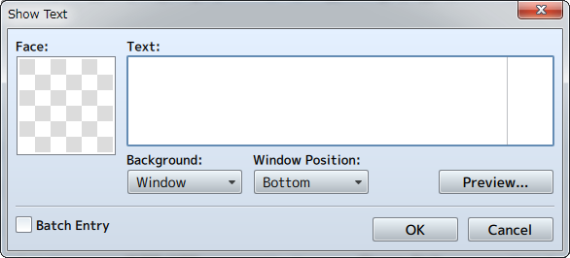

**Function**

Opens the Message Window and displays text.

**Settings**

**Face**

Specifies the face image to display in the left side of the Message Window. You can select an image in the [Select an Image] Window that appears after double-clicking in the image area.

**Text**

Input the text to display. It is possible to display up to 4 lines of text at once in the Message Window. Press the [Enter] key to go to the next line when wanting to display text after the 2nd line.

**Background**

Select the Message Window format that will display the text.

**Window Position**

Specify either [Bottom], [Middle] or [Top] for the display position of the Message Window.

**Preview**

You can check what will actually be displayed by clicking this.

**Batch Entry**

When enabled, it allows you to enter more than 4 lines of text. Text which exceeds 4 lines will be set in the contents window after dividing every 4 lines into multiple [Show Text] event commands.

**Remarks**

* Pressing [Ctrl] + [Enter] while inputting text is the same as pressing the [OK] button.
* The vertical line in the [Text] field is a guide for the amount of characters that are possible to display in the Message Window. To check whether the text is displayed as intended, enter text while checking the [Preview].
* You can display values of variables and names of actors by entering control characters into the text. Control characters and what will be displayed is as follows. Be sure to enter all control characters using half-width input.

|  |  |
| --- | --- |
| \V[n] | Will be replaced with the value of the nth variable. |
| \N[n] | Will be replaced with the name of the nth actor. |
| \P[n] | Will be replaced by the name of the nth (arranged order) party member. |
| \G | Will be replaced by the currency unit. |
| \C[n] | Draw the subsequent text in the nth color. Text color conforms to the contents of the [Window.png] system image. |
| \I[n] | Draws the nth icon. |
| \{ | Increases the text by 1 step. |
| \} | Decreases the text by 1 step. |
| \\ | Replaced with the backslash character. |
| \$ | Open the gold window. |
| \. | Wait for 1/4 second. |
| \| | Wait for 1 second. |
| \! | Wait for button input. |
| \> | Display remaining text on same line all at once. |
| \< | Cancel the effect that displays text all at once. |
| \^ | Do not wait for input after displaying the next. |

* The control characters \V, \N, \P, \G, \C, \I, \\ may be used in the below places as well.

* Event Command: [[Show Choices](https://rmmv.neocities.org/page/01_10_01.html#p02)]
* Database: [Profile] in [[Actor Settings](https://rmmv.neocities.org/page/01_08_01.html)]
* Database: [Message] in [[Skill Settings](https://rmmv.neocities.org/page/01_08_03.html)]
* Database: [Description] in [[Item Settings](https://rmmv.neocities.org/page/01_08_04.html)] and [[Weapon/Armor Settings](https://rmmv.neocities.org/page/01_08_05.html)]
* Database: [Messages] in [[State Settings](https://rmmv.neocities.org/page/01_08_08.html)]
* Database: [Save Message] and [Load Message] fields in [Messages] in [[Terms Settings](https://rmmv.neocities.org/page/01_08_14.html)]
* Database: In [Messages] in [[Terms Settings](https://rmmv.neocities.org/page/01_08_14.html)], the messages used during battle from [Party Name] and below (For things displayed in the window, \$ \. \| \! \> \< \^ may also be used)

**Show Choices**

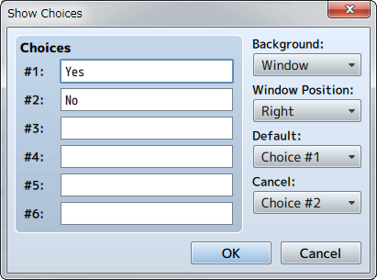

**Function**

Displays the Choices Window (up to 6 choices), and handles branches according to the player's choices. You can use control characters similar to how you use them in messages.

**Settings**

**Choices (1 through 6)**

Specifies the text for the choices. Choices left blank will not be displayed.

**Background**

Specifies the background type for choices.

**Window Position**

Specifies the display position of the choices on the screen.

**Default**

Specifies the initial position of the cursor.

**Cancel**

Handling method for when the cancel button is pressed.

**Remarks**

* After confirming your settings, all the branches that handle the choices (including Cancel) will be created in the [Contents] section. What will be run after selecting a choice will be set in these branches.

**Input Number**

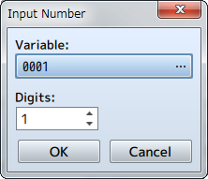

**Function**

Displays the Input Number screen, and assigns the value input by the player to a variable.

**Settings**

**Variable**

Specify the variable that will store the number specified by the player.

**Digits**

Specify the number of digits (1 through 8) that the input will accept.

**Select Item**

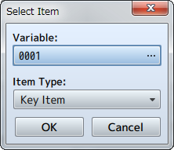

**Function**

Displays the Item Selection Window. Assigns the ID of the item that the player selects to a variable.

**Settings**

**Variable**

Specifies the variable that the item number (item ID) selected by the player will be assigned to.

**Item Type**

Specify the types of items to display in the list.

**Show Scrolling Text**

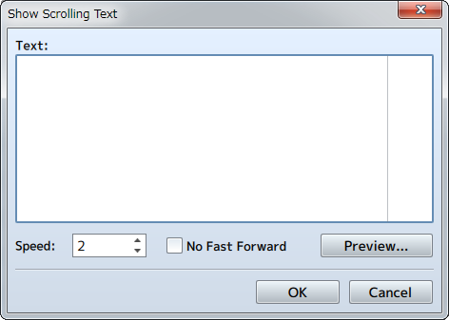

**Function**

Displays text that scrolls from the bottom to the top. Scrolling will be fast forwarded when the confirm button is pressed.

**Settings**

**Text**

Input the text to display.

**Speed**

Specifies the scroll speed (1 through 8). The higher the number, the faster the scrolling becomes.

**No Fast Forward**

Fast forwarding will not be possible when the confirm button is pressed.

Game Progression

**Control Switches**

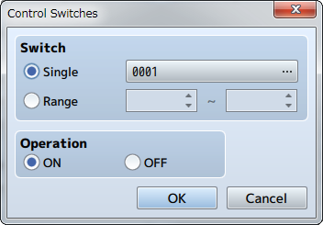

**Function**

Changes the values (ON/OFF) of switches.

**Settings**

**Switch**

Specifies the switch to change. Select [Single] when controlling one switch, and specify the target switch. Select [Range] when wanting to change the values of a group of switches, and specify the number range of the switches.

**Operation**

Specifies the value (ON/OFF) to store in the switch.

**Control Variables**

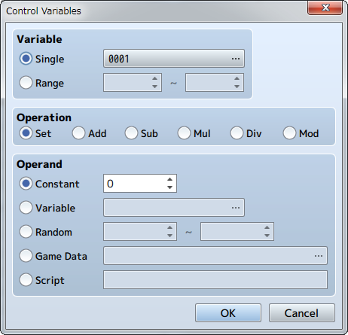

**Function**

Changes the value stored in a variable.

**Settings**

**Variable**

Specify the variable of the value you want to change. Select [Single] when controlling one variable, and specify the target variable. Select [Range] when wanting to change the values of a group of variables, and specify the number range of the variables.

**Operation**

Specify how the numbers will be calculated (refer to remarks). The variable calculated in [Variable] will change will change based on the value before the operation, method of calculation, and the operand.

**Operand**

Specifies the operand used for the [Operation] calculation (refer to remarks).

**Remarks**

* Details regarding the method of calculation specified under [Operation] are as follows.

|  |  |
| --- | --- |
| Set | Sets the value of the operand (no calculation). |
| Add | Sets a value calculated using [variable value before operation + operand]. |
| Sub | Sets a value calculated using [variable value before operation - operand]. |
| Mul | Sets a value calculated using [variable value before operation x operand]. |
| Divide | Sets a value calculated using [variable value before operation ÷ operand]. |
| Mod | Sets a value which is the remainder of [variable value before operation ÷ operand]. |

* Details regarding [Operand] are as follows. These can be set from -99999999 to 99999999).

|  |  |
| --- | --- |
| Constant | Uses a fixed value. Specify the value in the right field. |
| Variable | Uses a variable. Specify the variable to reference. |
| Random | Uses a random (number chosen randomly) value. Range of the random value that can be generated (-99999999 to 99999999) |
| Game Data | Uses a value related to the play state of the game. Specify the information to reference in the window that opens when you click [...](refer below). |
| Script | Use the result evaluated as JavaScript for the value. |

* When selecting [Game Data] as the [Operand], the type of data which the operand will be evaluated as will be one of the following.

|  |  |
| --- | --- |
| Item | Uses the possession count of the specified item. |
| Weapon | Uses the possession count of the specified weapon. |
| Armor | Uses the possession count of the specified armor. |
| Actor | Uses the actor's parameter (HP, MP, etc.) as the value. Specifies the target actor and parameter. |
| Enemy | Uses the enemy's parameter (HP, MP, etc.) as the value. Specifies the target enemy and parameter. This is only effective during battle. |
| Character | Uses values such as the coordinates and direction of the player or events.   |  |  | | --- | --- | | Map X, Map Y | ：Map coordinates of current location | | Direction | ：Current direction (up = 8 / left = 4 / right = 6 / down = 2) | | Screen X, Screen Y | ：Uses the display position coordinates on the screen (pixels) | |
| Party | Uses the ID of the actor at the specified position in the party. |
| Other | Uses all other data. |

**Control Self Switch**

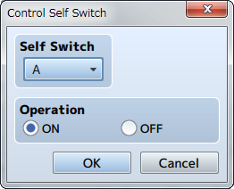

**Function**

Controls the value of self switches.

**Settings**

**Self Switch**

Specify the target self switch (A through D).

**Operation**

Specifies the value (ON/OFF) to store in the switch.

**Remarks**

* This cannot be used in battle events.

**Control Timer**

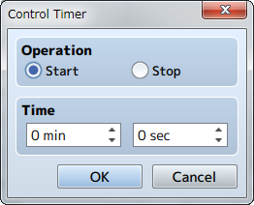

**Function**

Start/stop the timer that calculates the time limit (time remaining). Starting the timer will cause the time remaining to be displayed at the top right of the screen. The timer will temporarily stop (will not be calculated) while the menu is displayed. To branch a process using the time left on the timer, use the [Conditional Branch] event command.

**Settings**

**Operation**

Select [Start] to start calculating the time limit and select [Stop] to stop calculating it.

**Time**

In the case that [Start] was selected under [Operation], specify the time limit (0 minutes, 0 seconds to 99 minutes, 59 seconds).

Flow Control

**Conditional Branch**

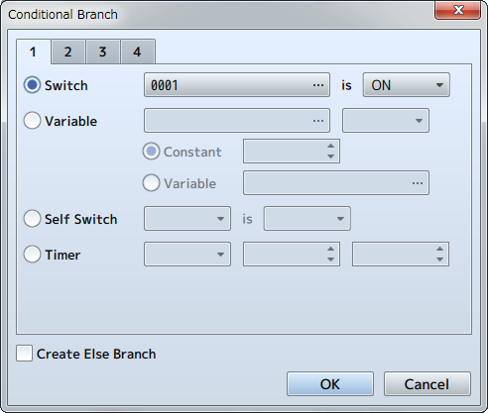

**Function**

Specifies event commands which branch processes so that it is possible to run special processes only when specified conditions are met. When [Create Else Branch] is enabled, it is possible to branch conditions when the specified conditions are not met.

**Settings**

Specifies the conditions from the below options along with the evaluation criteria.

**Switch**

Use the value of the specified switch as a criterion. Set the target switch and its value to (ON/OFF).

**Variable**

Use the value of the specified variable as a criterion. Set the variable used to evaluate conditions, the value to compare, and the method for comparison. When using a variable for the value to compare, select [Variable], and specify the value to reference.

**Self Switch**

Use the state of the specified self switch as a criterion. Set the target self switch and its value to (ON/OFF).

**Timer**

Use the remaining time on the timer as a criterion. Specify the remaining time and criterion (greater than/less than).

**Actor**

Use the specified actor as a criterion. Select the target actor, the content to reference (in party/name/class/skill/weapon/armor/state) and the evaluation criteria (specific item).

**Enemy**

Use the specified enemy during battle as a criterion. Select the target enemy and the evaluation criteria (appeared/state). This is only effective in battle events.

**Character**

Uses the direction of the player or map event as a criterion. Specify the target character and direction. This is only effective in map events.

**Vehicle**

Use whether the player is riding the specified vehicle (boat/ship/plane) as a criterion.

**Gold**

Use Gold possessed by the party as a criterion. Specify the amount and method for comparison (greater than/less than).

**Item**

Use whether the party possesses the specified item as a criterion.

**Weapon**

Use whether the party possesses the specified weapon as a criterion. When [Include Equipment] is enabled, the equipment that the actors are wearing will also be evaluated.

**Armor**

Use whether the party possesses the specified armor as a criterion. When [Include Equipment] is enabled, the equipment that the actors are wearing will also be evaluated.

**Button**

Use whether the specified button is pressed as a criterion.

**Script**

For advanced users: use the evaluation result of the script as a criterion.

**Loop**

**Function**

Adds the event commands [Loop] and [Repeat Above] which carry out repeated processes used for control. You can repeatedly run the event commands set in the rows found between these two commands. It is also possible to use a "multiloop" which runs additional loops inside other loops.

**Remarks**

* Event commands between [Loop] and [Repeat Above] will be repeated indefinitely. Use the event commands such as [Break Loop] to end repeated processes.

**Break Loop**

**Function**

Stops the process being repeated using the [Loop] event command. When this is run, the process will skip to the event command specified in the row after [Repeat Above]. There are no parameters to set.

**Exit Event Processing**

**Function**

Stops processing of the contents. Event commands after this will not be processed. There are no parameters to set.

**Common Event**

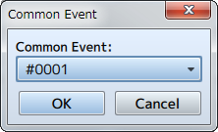

**Function**

Invokes common events. After the common event that was invoked is finished processing, the game will move to the next event command.

**Settings**

**Common Event**

Specify the common event to run.

**Label**

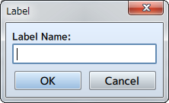

**Function**

Creates a jump location for processes via the [Jump to Label] event command.

**Settings**

**Label Name**

Specify the name of the label.

**Jump to Label**

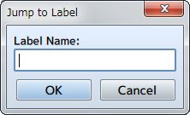

**Function**

The line to be processed moves to the location of the specified label. The event command of the row following the label that the process moved to will be processed.

**Settings**

**Label Name**

Specify the label name of the jump location. Only labels belonging to the same event page can be specified.

**Comment**

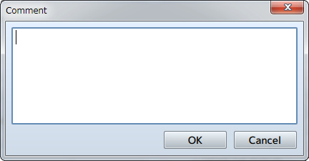

**Function**

Sets comments displayed in the contents list. Has no effect on the game.

**Settings**

**Comment**

Set the text to be displayed as comments.

Party

**Change Gold**

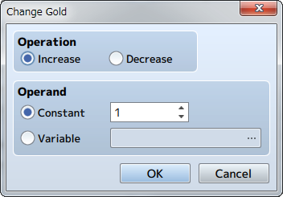

**Function**

Changes the amount of gold of the party.

**Settings**

**Operation**

Specify whether to increase or decrease gold.

**Operand**

Set the amount to increase or decrease gold. Choose [Constant] to change the gold using a fixed value, and enter the amount. Choose [Variable] to set the amount using a variable, and specify the variable to reference.

**Change Items**

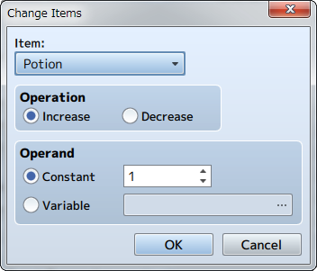

**Function**

Changes the quantity of items of the party. Upon changing the quantity, if that number is outside of the 0 to 99 range, the value will be adjusted to either 99 (max number a player can have) or 0 (none in inventory).

**Settings**

**Item**

Specify the item to increase or decrease.

**Operation**

Specify whether to increase or decrease the quantity.

**Operand**

Set the amount by which to increase or decrease the quantity. Choose [Constant] to change the quantity using a fixed value, and enter the amount. Choose [Variable] to set the amount using a variable, and specify the variable to reference.

**Change Weapons**

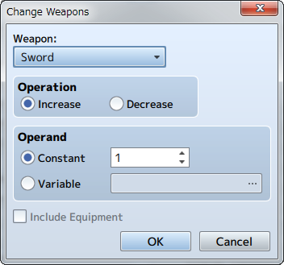

**Function**

Changes the quantity of weapons of the party. Upon changing the quantity, if that number is outside of the 0 to 99 range, the value will be adjusted to either 99 (max number a player can have) or 0 (none in inventory).

**Settings**

**Weapon**

Specify the weapon to increase or decrease.

**Operation**

Specify whether to increase or decrease the quantity.

**Operand**

Set the amount by which to increase or decrease the quantity. Choose [Constant] to change the quantity using a fixed value, and enter the amount. Choose [Variable] to set the amount using a variable, and specify the variable to reference.

**Include Equipment**

When enabled, weapons that actors have equipped can also be decreased.

**Change Armors**

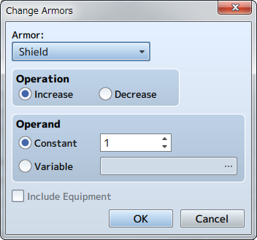

**Function**

Changes the quantity of armors of the party. Upon changing the quantity, if that number is outside of the 0 to 99 range, the value will be adjusted to either 99 (max number a player can have) or 0 (none in inventory).

**Settings**

**Armor**

Specifies the armor to increase or decrease.

**Operation**

Specifies whether to increase or decrease the quantity.

**Operand**

Set the amount by which to increase or decrease the quantity. Choose [Constant] to change the quantity using a fixed value, and enter the amount. Choose [Variable] to set the amount using a variable, and specify the variable to reference.

**Include Equipment**

When enabled, armor that actors have equipped can also be decreased.

**Change Party Member**

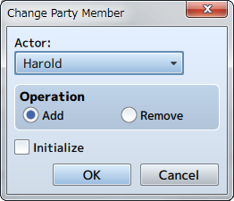

**Function**

Change the formation of the actors in the party. You can also change the number of actors in the party to 0 using this command. If so, players will not be displayed on the map.

**Settings**

**Actor**

Select the actor to change.

**Operation**

Select which operation to perform (Add/Remove).

**Initialize**

When enabled, the traits when adding an actor will be reset according to the parameters in the [Database].

Actor

* [RPG Maker MV](https://rmmv.neocities.org/page/01.html)

* >

* [Event Commands](https://rmmv.neocities.org/page/01_10.html)

* >

* Actor

**Change HP**

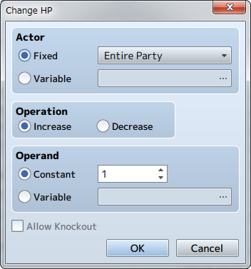

**Function**

Changes the HP of the actor.

**Settings**

**Actor**

Select the target actor. Select [Fixed] when wanting to select a specific actor and specify the actor (all members will be selected when selecting [Entire party]). Select [Variable] when wanting to select an actor using an ID number, and specify the value to reference.

**Operation**

Specify whether to increase or decrease the HP.

**Operand**

Specify the amount by which to raise or lower the HP. Select [Constant] to set this to a fixed value, and enter a value (1 to 9999). Choose [Variable] to set the amount using a variable, and specify the variable to reference.

**Allow Knockout**

When enabled, the actor will be knocked out when their HP falls below 0. When disabled, when the HP falls below 0, the HP will be set to 1.

**Change MP**

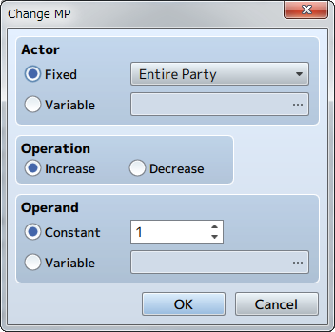

**Function**

Changes the MP of the actor.

**Settings**

**Actor**

Select the target actor. Select [Fixed] when wanting to select a specific actor and specify the actor (all members will be selected when selecting [Entire party]). Select [Variable] when wanting to select an actor using an ID number, and specify the value to reference.

**Operation**

Specify whether to increase or decrease the MP.

**Operand**

Specify the amount by which to raise or lower the MP. Select [Constant] to set this to a fixed value, and enter a value (1 to 9999). Choose [Variable] to set the amount using a variable, and specify the variable to reference.

**Change TP**

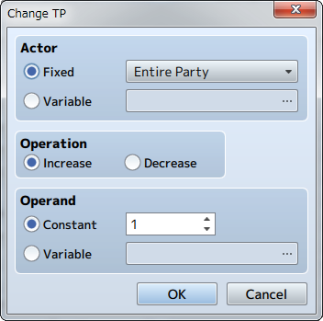

**Function**

Changes the TP of the actor.

**Settings**

**Actor**

Select the target actor. Select [Fixed] when wanting to select a specific actor and specify the actor (all members will be selected when selecting [Entire party]). Select [Variable] when wanting to select an actor using an ID number, and specify the value to reference.

**Operation**

Specify whether to increase or decrease the TP.

**Operand**

Specify the amount by which to raise or lower the TP. Select [Constant] to set this to a fixed value, and enter a value (1 to 100). Choose [Variable] to set the amount using a variable, and specify the variable to reference.

**Change State**

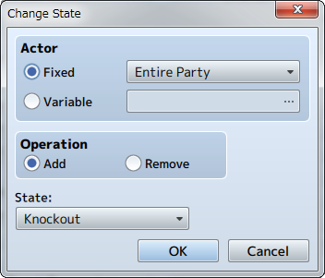

**Function**

Changes the state of the actor.

**Settings**

**Actor**

Select the target actor. Select [Fixed] when wanting to select a specific actor and specify the actor (all members will be selected when selecting [Entire party]). Select [Variable] when wanting to select an actor using an ID number, and specify the value to reference.

**Operation**

Specify the content (Add/Remove) of the operation.

**State**

Specify the state that will be added or removed.

**Recover All**

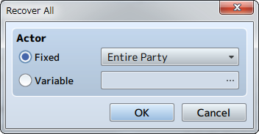

**Function**

Fully recovers the HP and MP of the actor, and removes all states.

**Settings**

**Actor**

Select the target actor. Select [Fixed] when wanting to select a specific actor and specify the actor (all members will be selected when selecting [Entire party]). Select [Variable] when wanting to select an actor using an ID number, and specify the value to reference.

**Change EXP**

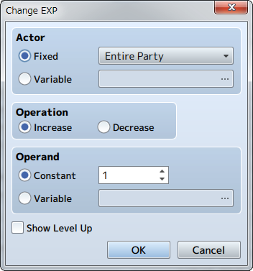

**Function**

Changes the EXP of the actor.

**Settings**

**Actor**

Select the target actor. Select [Fixed] when wanting to select a specific actor and specify the actor (all members will be selected when selecting [Entire party]). Select [Variable] when wanting to select an actor using an ID number, and specify the value to reference.

**Operation**

Specify whether to increase or decrease the EXP.

**Operand**

Specify the amount by which to raise or lower the EXP. Select [Constant] to set this to a fixed value, and enter a value (1 to 99999999). Choose [Variable] to set the amount using a variable, and specify the variable to reference.

**Show Level Up**

When enabled, a message will be displayed on the Play Screen indicating if an actor leveled up after their EXP increased.

**Change Level**

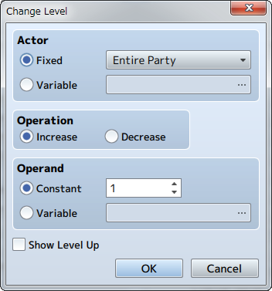

**Function**

Changes the level of the actor.

**Settings**

**Actor**

Select the target actor. Select [Fixed] when wanting to select a specific actor and specify the actor (all members will be selected when selecting [Entire party]). Select [Variable] when wanting to select an actor using an ID number, and specify the value to reference.

**Operation**

Specify whether to increase or decrease the level.

**Operand**

Specify the amount by which to raise or lower the level. Select [Constant] to set this to a fixed value, and enter a value (1 to 98). Choose [Variable] to set the amount using a variable, and specify the variable to reference.

**Show Level Up**

When enabled, a message will be displayed on the Play Screen indicating if an actor leveled up after their level increased.

**Change Parameter**

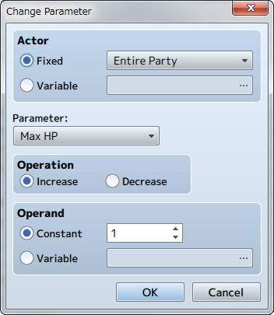

**Function**

Changes the actor's parameters.

**Settings**

**Actor**

Select the target actor. Select [Fixed] when wanting to select a specific actor and specify the actor (all members will be selected when selecting [Entire party]). Select [Variable] when wanting to select an actor using an ID number, and specify the value to reference.

**Parameter**

Specify the type of parameter to increase or decrease.

**Operation**

Specify whether to increase or decrease the parameter.

**Operand**

Specify the amount by which to raise or lower the parameter. Select [Constant] to set this to a fixed value, and enter a value (1 to 9999). Choose [Variable] to set the amount using a variable, and specify the variable to reference.

**Change Skill**

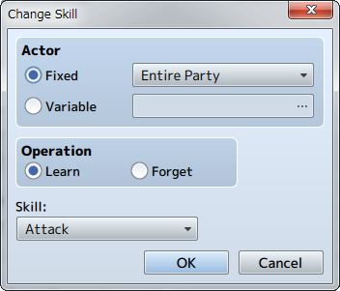

**Function**

Controls the skills that actors can use.

**Settings**

**Actor**

Select the target actor. When selecting a specific actor, select [Fixed] and specify the actor. Select [Variable] when wanting to select an actor using an ID number, and specify the value to reference.

**Operation**

Select [Learn] to make a skill useable, and select [Forget] to make it unusable.

**Skill**

Specify the skill that will be added or removed.

**Change Equipment**

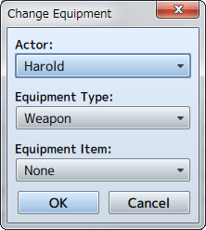

**Function**

Changes the equipment of the actor.

**Settings**

**Actor**

Select the target actor.

**Equipment Type**

Specify the type of equipment to change.

**Equipment Item**

Specify the new equipment to equip. A party must possess the specified equipment.

**Remarks**

* Equipment will not be changed in the party does not possess the specified equipment item. To forcibly equip an item, you must first give the equipment armor to the party using the [Change Weapons] and [Change Armors] event commands.

**Change Name**

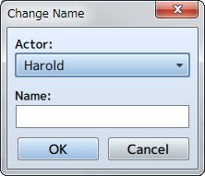

**Function**

Changes the name of the actor.

**Settings**

**Actor**

Select the target actor.

**Name**

Specify the name after changing it.

**Change Class**

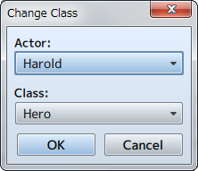

**Function**

Changes the class of the actor.

**Settings**

**Actor**

Select the target actor.

**Class**

Specify the class to be changed to.

**Remarks**

* The actor’s level is set to 1 when class has been changed. You can adjust the actor’s status after changing classes by changing [Change Level] and [Change EXP].
* Equipment and armor that cannot be equipped will automatically be unequipped.

**Change Nickname**

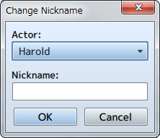

**Function**

Changes the nickname of the actor.

**Settings**

**Actor**

Select the target actor.

**Nickname**

Specify the nickname after changing it.

**Change Profile**

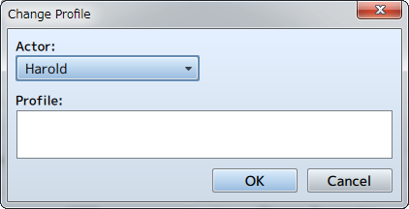

**Function**

Changes the profile of the actor.

**Settings**

**Actor**

Select the target actor.

**Profile**

Specify the profile after changing it.

Movement

**Transfer Player**

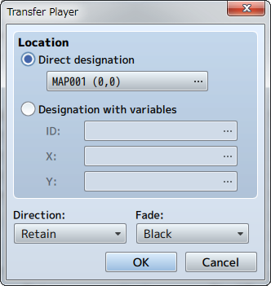

**Function**

Changes the location of the party.

**Settings**

**Location**

Specify the location after changing it. To move a party to a specific location, select [Direct designation], and click to specify the location to move the party in the window that is displayed when you click [...]. To specify the location using a map ID and coordinates, select [Designation with variables], and specify the variables to reference in [ID], [X], [Y].

**Direction**

Specify the direction of the player after being transferred.

**Fade**

Specify how the screen will transition during a transfer. The screen will be displayed in black when choosing [Black] and [White] when choosing white, followed by displaying the new map location.

**Set Vehicle Location**

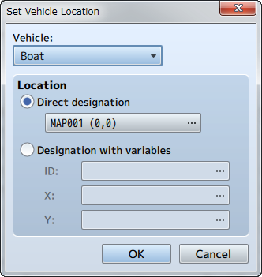

**Function**

Changes the location of vehicles.

**Settings**

**Vehicle**

Specify the target vehicle (boat/ship/plane).

**Location**

Specify the location after changing the location. To move a vehicle to a specific location, select [Direct designation], and click to specify the location to move the vehicle in the window that is displayed when you click [...]. To specify the location using a map ID and coordinates, select [Designation with variables], and specify the variables to reference in [ID], [X], [Y].

**Set Event Location**

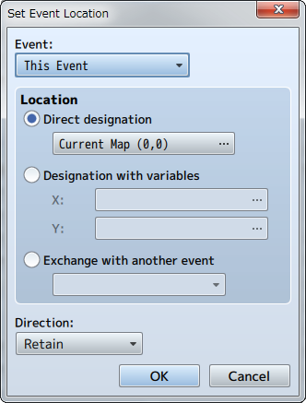

**Function**

Changes the location of an event.

**Settings**

**Events**

Specify the target event. By setting this to [This Event], the event itself will be the target for changing the location. Moving the event is limited to the same map.

**Location**

Specify the location after changing the location. To move an event to a specific location, select [Direct designation], and click to specify the location to move the event in the window that is displayed when you click [...]. To specify the location using a map ID and coordinates, select [Designation with variables], and specify the variables to reference in [ID], [X], [Y].

**Direction**

Specify the direction of the event after being moved.

**Remarks**

* This cannot be used in battle events.

**Scroll Map**

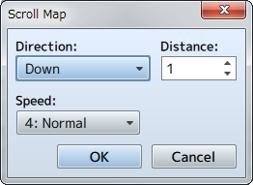

**Function**

Moves (scrolls) the range of the map displayed while playing without changing the location of the player.

**Settings**

**Direction**

Specify the direction to scroll.

**Distance**

Specify the distance (number of tiles) to move.

**Speed**

Specify the speed (6 levels) of the scrolling.

**Remarks**

* This cannot be used in battle events.

**Set Movement Route**

**Function**

Forces the player or map event to move along a specified route.  
For more information please refer to [[Set Movement Route](https://rmmv.neocities.org/page/01_10_06_01.html)].

**Remarks**

* Characters set on a movement route will start to move immediately.
* Using this event command on characters which are already set on movement routes will cause those settings to be abandoned, and only the new settings will be active. Choose [Wait for Completion] when wanting to set the next route after the movement from a previous route is completed.
* When [Wait for Completion] is enabled, the player cannot perform any actions until the movement command has finished (excluding processes running in parallel). If the character on the specified movement route runs into any obstacles during this time and the movement command is no longer able to run, the event will stop at that point. Enable options such as [Skip If Cannot Move] to avoid these sort of situations.
* The player's total number of steps will not be added using this event command even if they move.
* This cannot be used in battle events.

**Get on/off Vehicle**

**Function**

Controls getting on and off vehicles. The player will get off onto the ground when on the vehicle, and get on the vehicle when not on it. There are no parameters to set.

**Remarks**

* This event forces the player to get on or off the vehicle just as when they use the [Action] key. Nothing will happen if there are no vehicles available that can normally be ridden (when there are no vehicles that can be boarded and when there is no ground to move to).
* This cannot be used in battle events.

Set Movement Route

**What is a Movement Route?**

A movement route determines how a player or event will move. This is set if [Custom] is selected in the event's [Autonomous Movement] settings, as well as when using [Set Movement Route].  
  
Either setting will be carried out in the [Set Movement Route] window. Routes can be edited when used with [Movement Commands] that control the movement, direction, etc. of the player. For example, entering in the [Move Right], [Move Down], [Move Left] and [Move Up] movement commands will cause the player, etc. to move in a loop going clockwise from their current location.

**Parameter Details**

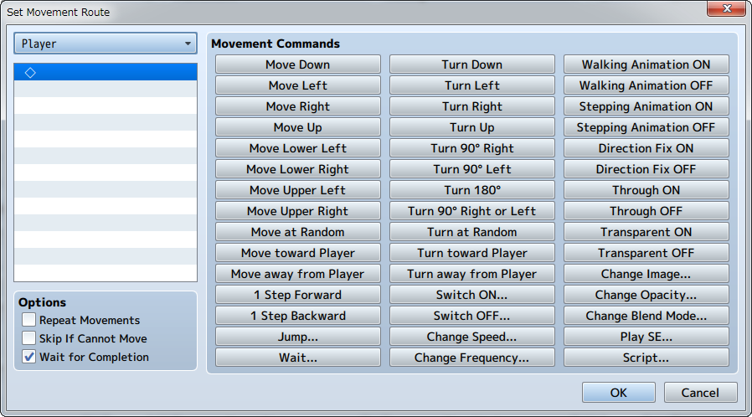

**Player**

Specify the target actor/event for the movement route. This will be set only when configuring the [Set Movement Route] event command.

**Command List**

List of movement commands that have been entered. Movement commands are entered in the order of the route that will be set here.  
  
Movement commands clicked in the movement command list will be added at the position of the item clicked in the list. Additionally, you can perform actions such as reediting settings and copying them using the context menu that is displayed when you right-click an item.

**Movement Commands**

Group of commands to control the movement and direction of characters (players/events). A command will be added (inserted) at the location which is currently selected in the command list by clicking a command's button. The movement for each command is as follows. The movement distance for 1 step is equal to one tile.

**Move Down/Move Left/Move Right/Move Up/Move Lower Left/Move Lower Right/Move Upper Left/Move Upper Right**

Move 1 step in the direction indicated in the command's name.

**Move at Random**

Move 1 step in a randomly selected direction between up, down, left and right.

**Move toward Player**

Move 1 step towards the direction of the player.

**Move away from Player**

Move 1 step in the direction away from the player.

**1 Step Forward**

Move 1 step in the direction currently faced.

**1 Step Backward**

Move 1 step away from the direction currently faced.

**Jump**

Move using a jump. Specify the distance to jump by setting the [X coordinate] and [Y coordinate] (each can be between -100 and 100, with a positive value being in the right/down direction). Players will move through obstacles during a jump. Moreover, members from the 2nd party member and on will remain in that location for parties which have [Show Player Followers] set to ON when jumping.

**Wait**

Specify the time to stop the process in number of frames (1 to 999). 1 frame is equal to 1/60th of a second.

**Turn Down/Turn Left/Turn Right/Turn Up**

Change the direction faced using the direction in the name.

**Turn 90° Right/Turn 90° Left**

Change the direction faced by 90° using the direction in the name.

**Turn 180°**

Face the opposite of the direction currently faced.

**Turn 90° Right or Left**

Change the direction randomly by 90°.

**Turn at Random**

Face up, down, left or right randomly.

**Turn toward Player**

Face toward where the player is.

**Turn away from Player**

Face the opposite direction of where the player is.

**Switch ON/Switch OFF**

Change the specified switch to the value in the name of the command.

**Change Speed**

Change the [Speed] setting under [Autonomous Movement] of the target map event. This change will continue even after movement has finished.

**Change Frequency**

Change the [Frequency] setting under [Autonomous Movement] of the target map event. This change will continue even after movement has finished.

**Walking Animation ON/Walking Animation OFF**

Change the value of the [Walking] setting under [Options] of the target map event. This change will continue even after movement has finished.

**Stepping Animation ON/Stepping Animation OFF**

Change the value of the [Stepping] setting under [Options] of the target map event.

**Direction Fix ON/Direction Fix OFF**

Change the value of the [Direction Fix] setting under [Options] of the target map event. This change will continue even after movement has finished.

**Through ON/Through OFF**

Change the value of the [Through] setting under [Options] of the target map event. This change will continue even after movement has finished.

**Transparent ON/Transparent OFF**

Change the image of the character to be displayed/hidden. The character will not be displayed when this is set to ON. This change will continue even after movement has finished.

**Change Image**

Change the character's image to the specified image. This change will continue even after movement has finished.

**Change Opacity**

Change the opacity (0 to 255) of the image of the character. The image will be invisible when this is set to 0. This change will continue even after movement has finished.

**Change Blend Mode**

Change the blending method of the colors displayed for the characters and map. Setting this to [Additive] will make it whitish. This change will continue even after movement has finished.

**Play SE**

Play the specified SE.

**Script**

Run the loaded script.

**Options**

This is a way to processes all movement commands entered into the command list. Enable the processes to apply as necessary.

**Repeat Movements**

When enabled, the contents of the command list will be run repeatedly.

**Skip If Cannot Move**

When enabled, the processes will be skipped when it is not possible to move via movement commands due to things like obstacles.

**Wait for Completion**

When enabled, all other processes will be temporarily stopped until all vent commands are finished being processed. This will be set only when configuring the [Set movement Route] event command.

Character

**Change Transparency**

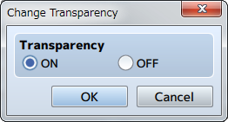

**Function**

Controls the display (transparency) of the party moving on the map.

**Settings**

**Transparency**

Set to [ON] to make the party invisible, set it to [OFF] to make the party visible.

**Change Player Followers**

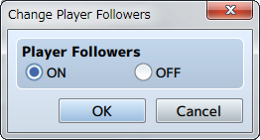

**Function**

Controls whether or not the party members from the 2nd member and on are displayed while walking.

**Settings**

**Player Followers**

Set to [ON] to make the party visible, set it to [OFF] to hide the party.

**Remarks**

* Only 4 actors starting from the first will be displayed even when there are 5 members in a party.

**Gather Followers**

**Function**

Moves all party members to the same location as the lead actor. There are no parameters to set.

**Show Animation**

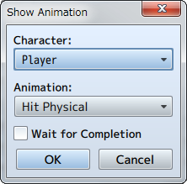

**Function**

Shows animations on the map.

**Settings**

**Character**

The display location will be based on the position of the player and events.

**Animations**

Specify the animation to display.

**Wait for Completion**

When enabled, the event will be paused until the animation being displayed has finished.

**Remarks**

* This cannot be used in battle events.
* Use the [Show Battle Animation] event command when wanting to play an animation during battle.

**Show Balloon Icon**

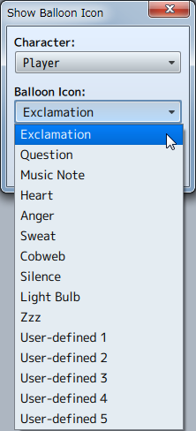

**Function**

Display icons that express emotions using balloons that appear over the party and events. 10 types of icons such as "!" for being surprised and a light bulb when a character has a good idea are available. It is also possible for users to define their own balloon icons.

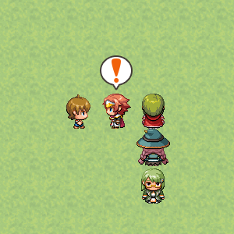

**Settings**

**Character**

The display location will be based on the position of the player and events.

**Balloon Icon**

Specify the balloon icon to display.

**Wait for Completion**

When enabled, the event will be paused until the balloon icon being displayed has disappeared.

**Erase Event**

**Function**

Temporarily removes the event currently being run. There are no parameters to set. The event will remain erased until the party moves to another map.

**Remarks**

* This cannot be used in battle events.

Picture

**Show Picture**

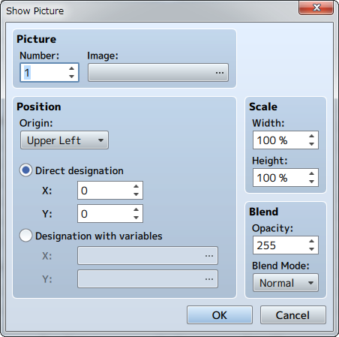

**Function**

Displays a picture (static image) on the screen.

**Settings**

**Picture: Number**

Specify a control number (1 to 100) to link to the picture.

**Picture: Image**

Specify the picture to display.

**Position**

Specify the display position of the picture. First, select the [Origin Point] of the picture which can be the [Upper Left] or [Center] of the screen. After doing so, specify the position using coordinates which will use (0, 0) as the origin. When using [Direct designation], enter in coordinates (-9999 to 9999) for [X] which will be the horizontal position, and [Y] which will be the vertical position. To specify the location using variables to specify coordinates, select [Designation with variables], and specify the variables for [X], and [Y].

**Scale**

Specify the percentage to scale the image (between 0 and 2000% with 100% being the original size) using the [Width] and [Height] fields.

**Blend**

Specify the opacity (0 to 255) of the picture under [Opacity]. The smaller the value, the more transparent the picture will be (will not be displayed if 0). Specify how to blend the image colors when changing the opacity of the image under [Blending Mode]. The image will be blended normally when [Normal] is selected, and will appear whiter when [Additive] is selected.

**Remarks**

* 100 pictures can be displayed at one time. The higher the control number, the higher it will be prioritized when displayed.
* If there are multiple of the same control number, only the picture that was displayed last will be displayed (all earlier pictures will be erased).

**Move Picture**

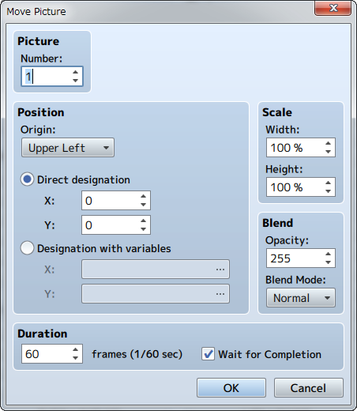

**Function**

Moves the currently displayed picture.

**Settings**

**Picture: Number**

Specify the control number (1 to 100) for the target picture.

**Position**

Specifies the position of the picture after it has been moved. First, select the [Origin Point] of the picture which can be the [Upper Left] or [Center] of the screen. Next, specify the position using coordinates which will use (0, 0) as the origin. When using [Direct designation], enter in coordinates (-9999 to 9999) for [X] which will be the horizontal position, and [Y] which will be the vertical position. To specify the location using variables to specify coordinates, select [Designation with variables], and specify the variables for [X], and [Y].

**Scale**

Specify the percentage (0 to 2000%) by which to scale the [Width] and [Height] of the picture after it has been moved.

**Blend**

Specify the opacity (0 to 255) of the picture after it has been moved under [Opacity]. The smaller the value, the more transparent the picture will be (will not be displayed if 0). Specify how to blend the image colors when changing the opacity of the image under [Blending Mode]. The image will be blended normally when [Normal] is selected, and will appear whiter when [Additive] is selected.

**Time**

Specify the amount of time moving the picture will take in number of frames (1 to 999). 1 frame is equal to 1/60th of a second.

**Wait for Completion**

When enabled, processing will wait for this event command to finish.

**Rotate Picture**

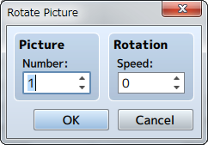

**Function**

Rotates the displayed picture.

**Settings**

**Picture: Number**

Specify the control number (1 to 100) for the target picture.

**Rotation: Speed**

Specify how fast the picture is rotated (-90 to 90). It will be rotated counterclockwise when this number is positive, and clockwise when negative. Set this value to 0 to stop rotating the picture.

**Remarks**

* The rotation axis (center point) will be set to the origin that was specified for the target picture when it's last displayed/moved.

**Tint Picture**

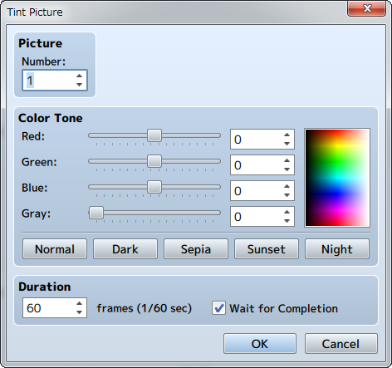

**Function**

Changes the color tone of the picture that is displayed.

**Settings**

**Picture: Number**

Specify the control number (1 to 100) for the target picture.

**Color Tone**

Specifies the amount of each [Red], [Green] and [Blue] to add (-255 to 255). Set the strength of the gray scale filter (0 to 255) by changing the [Gray] value. The higher the value, the stronger the overall color tone will be. Check the color tone using the preview area on the right.

**Time**

Specify the amount of time changing the tint of the picture will take in number of frames (1 to 999). 1 frame is equal to 1/60th of a second.

**Wait for Completion**

When enabled, processing will wait for this event command to finish.

**Remarks**

* The changed color tone will be effective until updated again by this event command.

**Erase Picture**

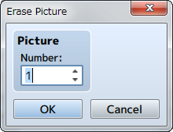

**Function**

Erases the picture displayed.

**Settings**

**Picture: Number**

Specify the control number (1 to 100) for picture to be deleted.

Timing

**Wait**

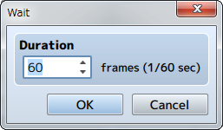

**Function**

Temporarily stops the event. While stopped, the player cannot perform any actions (excluding processes running in parallel).

**Settings**

**Duration**

Specify the time to stop the process in number of frames (1 to 999). 1 frame is equal to 1/60th of a second.

Screen

**Fadeout Screen**

**Function**

Fades out the screen (slowly fades the screen into black). There are no parameters to set.

**Remarks**

* The screen will remain faded out until the [Fadein Screen] event command is run.
* Elements such as the menu, message windows and battle command window will still be visible even while faded out.
* If run during a battle event, everything except the command window and messages will appear black, and enemies, etc. will not be visible.

**Fadein Screen**

**Function**

Returns the screen back to normal after using [Fadeout Screen]. There are no parameters to set.

**Tint Screen**

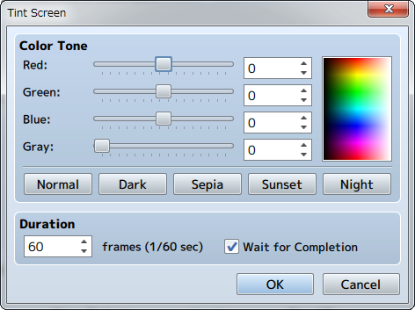

**Function**

Changes the color tone of the entire screen. The color tone of pictures and message windows will not change.

**Settings**

**Color Tone**

Specify the amount of each [Red], [Green] and [Blue] to add (-255 to 255). Set the strength of the gray scale filter (0 to 255) by changing the [Gray] value. The higher the value, the stronger the overall color tone will be. By clicking the [Normal], [Dark], [Sepia], [Sunset] and [Night] buttons below, values representing each color tone will be applied ([Normal] will return the color tone back to its original setting). Check the color tone using the preview area on the right.

**Duration**

Specify the amount of time changing the tint of the picture will take in number of frames (1 to 999). 1 frame is equal to 1/60th of a second.

**Wait for Completion**

When enabled, processing will wait for this event command to finish.

**Remarks**

* This color tone will remain in effect, including during battle, until using this event command is used again to change the settings.

**Flash Screen**

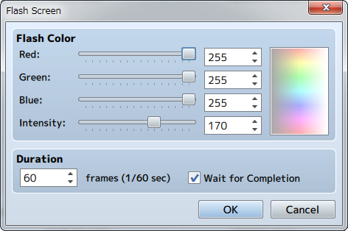

**Function**

Causes the entire screen to change to the specified color for just an instant, and will slowly return back to normal. You can use this to express things like lightning.

**Settings**

**Flash Color**

Specify the color to display based on each of the [Red], [Green] and [Blue] component values (0 to 255). The specified color can be checked in the preview area on the right. [Intensity] sets the opacity (0 to 255) of the color. Putting this to 0 will cause it to be completely transparent, and will not affect what appears on the screen.

**Duration**

Specify the amount of time the flash will last in number of frames (1 to 999). 1 frame is equal to 1/60th of a second.

**Wait for Completion**

When enabled, processing will wait for this event command to finish.

**Shake Screen**

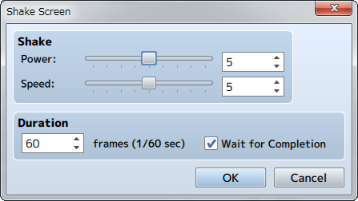

**Function**

Shakes the entire screen left to right.

**Settings**

**Shake**

Set the size (1 to 9) of the shaking range using the [Power] parameter, and the speed (1 to 9) of the shaking using the [Speed] parameter.

**Duration**

Specify the amount of time the shaking will last in number of frames (1 to 999). 1 frame is equal to 1/60th of a second.

**Wait for Completion**

When enabled, processing will wait for this event command to finish.

**Set Weather Effect**

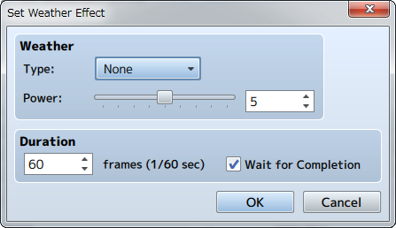

**Function**

Controls the display of effects which represent weather (rain/storm/snow).

**Settings**

**Type**

Specify the type of image to display. Set to [None] to stop displaying an image.

**Power**

Specify the amount of images to display (1 to 9).

**Duration**

Specify the amount of time changing the weather will take in number of frames (1 to 999). 1 frame is equal to 1/60th of a second.

**Wait for Completion**

When enabled, processing will wait for this event command to finish.

**Remarks**

* This cannot be used in battle events.

Audio & Video

**Play BGM**

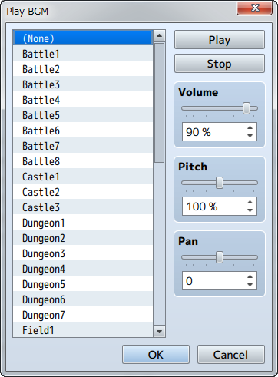

**Function**

Starts playing the BGM (background music).

**Settings**

**File List**

Select the BGM file to play. Set to [(None)] to stop playing the music.

**Play/Stop**

By clicking [Play], BGM will start playing using the current settings. Click [Stop] to stop the music.

**Volume**

Specify the volume.

**Pitch**

Specify the pitch (50 to 150%). When this is set to over 100%, the playback speed becomes faster and the musical scale gets higher.

**Pan**

Set the pan (-100 to 100). The majority of the sound comes out of the left speaker when this is a negative value, and more on the right when set to a positive value.

**Remarks**

* This event will not run if the specified BGM is already playing.

**Fadeout BGM**

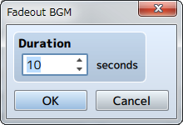

**Function**

Stops the playback while lowering the volume of the BGM.

**Settings**

**Duration**

Specify the amount of seconds (1 to 60) the fade-out takes.

**Save BGM**

**Function**

Saves the BGM currently being playing including the playtime position. There are no parameters to set.

**Replay BGM**

**Function**

Saves the BGM currently being playing including the playtime position. There are no parameters to set.

**Play BGS**

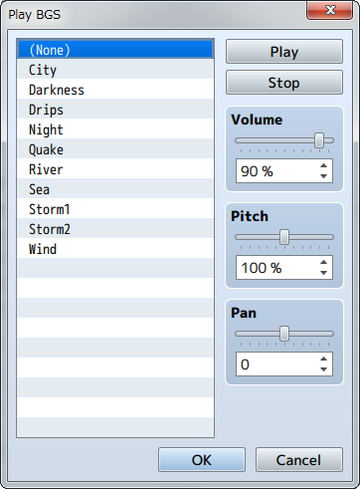

**Function**

Starts playing the BGS (background sound).

**Settings**

**File List**

Select the BGS file to play. Set to [(None)] to stop playing the sound.

**Play/Stop**

By clicking [Play], BGS will start playing using the current settings. Click [Stop] to stop the BGS.

**Volume**

Specify the volume.

**Pitch**

Specify the pitch (50 to 150%). When this is set to over 100%, the playback speed becomes faster and the sound scale gets higher.

**Pan**

Sets the pan (-100 to 100). The majority of the sound comes out of the left speaker when this is a negative value, and more on the right when set to a positive value.

**Remarks**

* This event will not run if the specified BGS is already playing.

**Fadeout BGS**

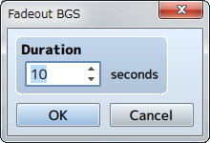

**Function**

Stops the playback while lowering the volume of the BGS.

**Settings**

**Duration**

Specify the amount of seconds (1 to 60) the fade-out takes.

**Play ME**

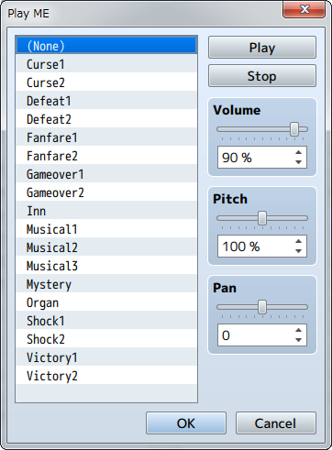

**Function**

Starts playing the ME (effects music).

**Settings**

**File List**

Select the ME file to play. Set to [(None)] to stop playing the ME.

**Play/Stop**

By clicking [Play], ME will start playing using the current settings. Click [Stop] to stop the music.

**Volume**

Specify the volume.

**Pitch**

Specify the pitch (50 to 150%). When this is set to over 100%, the playback speed becomes faster and the scale gets higher.

**Pan**

Set the pan (-100 to 100). The majority of the sound comes out of the left speaker when this is a negative value, and more on the right when set to a positive value.

**Remarks**

* This event will not run if the specified ME is already playing.

**Play SE**

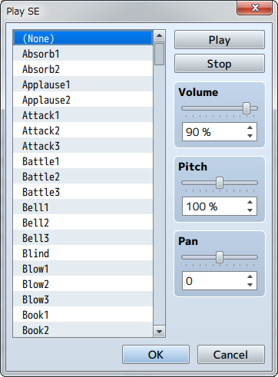

**Function**

Starts playing the SE (sound effects).

**Settings**

**File List**

Select the SE file to play.

**Play/Stop**

By clicking [Play], SE will start playing using the current settings. Click [Stop] to stop the SE.

**Volume**

Specify the volume.

**Pitch**

Specify the pitch (50 to 150%). When this is set to over 100%, the playback speed becomes faster and the scale gets higher.

**Pan**

Sets the pan (-100 to 100). The majority of the sound comes out of the left speaker when this is a negative value, and more on the right when set to a positive value.

**Remarks**

* If this command is run before the SE finishes playing, sound effects will be played on top of each other.
* SE will not stop playing even if [(None)] is played. Please use the Stop SE event command to stop SE from playing.

**Stop SE**

**Function**

Stops the playback of all SE (sound effects). There are no parameters to set.

**Play Movie**

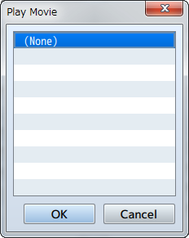

**Function**

Plays a movie.

**Settings**

**File List**

Select the movie file to play.

Scene Control

**Battle Processing**

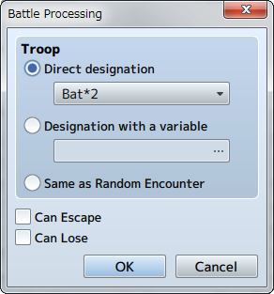

**Function**

Causes troops to appear and starts a battle.

**Settings**

**Troop**

Specify the troop that the player will fight against. Choose "Direct designation" and select the troop to have the player fight against a specific troop. To specify a troop by ID, choose "Designation with a variable" and enter in the value to reference. If you choose "Same as Random Encounter", the chosen troop will appear based on the [Encounter] settings of the map that the party is currently in.

**Can Escape**

When enabled, the [Escape] command will be enabled during battle, and you can make conditional branches based on "if player won" and "if player escaped".

**Can Lose**

When enabled, there will not be a game over even if the entire party is defeated, and you can make conditional branches based on "if player won" and "if player lost".

**Remarks**

* This cannot be used in battle events.

**Shop Processing**

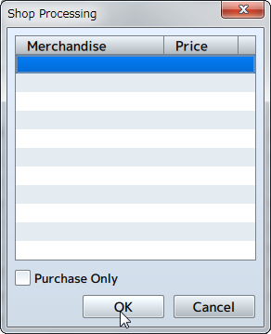

**Function**

Calls the shop screen where the player can buy weapons, armors and items.

**Settings**

**Merchandise**

Specify the items to sell. Set the [Merchandise] and [Price] in the window that is displayed when you double-click an empty row in the list. Choosing [Standard] will set the price to what was set in the data, and choosing [Specify] will set this price only to what is specified using this event command.

**Purchase Only**

When enabled, the player will be unable to sell items.

**Remarks**

* This cannot be used in battle events.

**Name Input Processing**

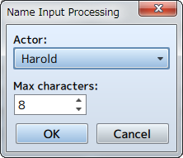

**Function**

Displays the name input screen for actors, and the actors name will be changed according to the input of the player.

**Settings**

**Actor**

Specify which actor will have their name changed.

**Max characters**

Specify the max amount of characters (1 to 16) for the name.

**Remarks**

* This cannot be used in battle events.
* When entering a name while playing, you can move the cursor using the D-pad, and enter characters using the confirm button and delete the last character using the delete button.

**Open Menu Screen**

**Function**

Calls the Menu Screen. There are no parameters to set.

**Remarks**

* This cannot be used in battle events.

**Open Save Screen**

**Function**

Calls the Save Screen. There are no parameters to set.

**Remarks**

* This cannot be used in battle events.

**Game Over**

**Function**

Forces the game to end and displays the Game Over Screen. There are no parameters to set.

**Return to Title Screen**

**Function**

Forces the game to end and returns to the Title Screen. There are no parameters to set.

System Settings

**Change Battle BGM**

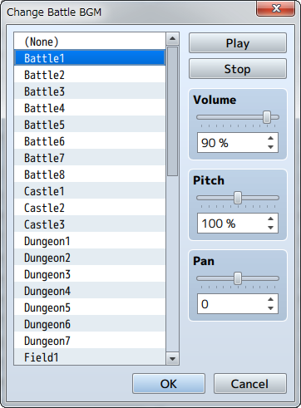

**Function**

Changes the settings of the BGM that plays during battle. These settings will be left unchanged until changed using this event command again.

**Settings**

**File List**

Specify the BGM file that will be used. Select [(None)] if you do not want to play a file.

**Play/Stop**

By clicking [Play], BGM will start playing using the current settings. Click [Stop] to stop the BGM.

**Volume**

Specify the volume.

**Pitch**

Specify the pitch (50 to 150%). When this is set to over 100%, the playback speed becomes faster and the scale gets higher.

**Pan**

Set the pan (-100 to 100). The majority of the sound comes out of the left speaker when this is a negative value, and more on the right when set to a positive value.

**Remarks**

* If this is changed during battle, the settings will take effect from the next battle.
* When the map and battle BGM is identical, the music will not stop when switching between screens.

**Change Victory ME**

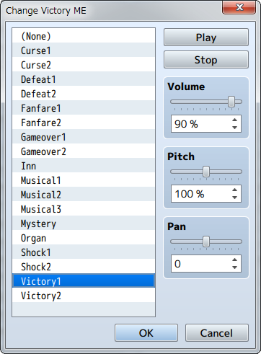

**Function**

Changes the settings for the ME that plays when winning a battle. These settings will be left unchanged until changed using this event command again.

**Settings**

**File List**

Specify the ME file that will be used. Select [(None)] if you do not want to play a file.

**Play/Stop**

By clicking [Play], ME will start playing using the current settings. Click [Stop] to stop the ME.

**Volume**

Specify the volume.

**Pitch**

Specify the pitch (50 to 150%). When this is set to over 100%, the playback speed becomes faster and the scale gets higher.

**Pan**

Sets the pan (-100 to 100). The majority of the sound comes out of the left speaker when this is a negative value, and more on the right when set to a positive value.

**Change Defeat ME**

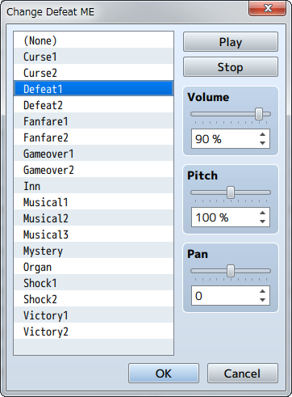

**Function**

Changes the settings for the ME that plays when losing a battle. These settings will be left unchanged until changed using this event command again.

**Settings**

**File List**

Specify the ME file that will be used. Select [(None)] if you do not want to play a file.

**Play/Stop**

By clicking [Play], ME will start playing using the current settings. Click [Stop] to stop the ME.

**Volume**

Specify the volume.

**Pitch**

Specify the pitch (50 to 150%). When this is set to over 100%, the playback speed becomes faster and the sound scale gets higher.

**Pan**

Set the pan (-100 to 100). The majority of the sound comes out of the left speaker when this is a negative value, and more on the right when set to a positive value.

**Change Vehicle BGM**

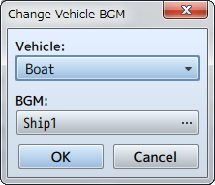

**Function**

Changes the settings for the BGM music that plays when riding a vehicle.

**Settings**

**Vehicle**

Specify the vehicle for the BGM.

**BGM**

Specify the BGM that will be played.

**Change Save Access**

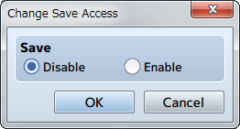

**Function**

Changes whether or not the game can be saved by the player. These settings will be left unchanged until changed using this event command again.

**Settings**

**Save**

Set this to [Disable] to prevent the player from saving, and [Enable] to allow the player to save.

**Change Menu Access**

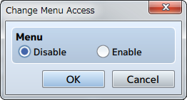

**Function**

Changes whether or not the Menu Screen can be called by the player. These settings will be left unchanged until changed using this event command again.

**Settings**

**Menu**

Set this to [Disable] to prevent the player from opening the Menu Screen, and [Enable] to allow the player to open the Menu Screen.

**Change Encounter**

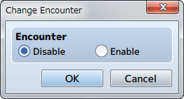

**Function**

Controls whether or not encounters (process that randomly causes a battle against a troop) occur. These settings will be left unchanged until changed using this event command again.

**Settings**

**Encounter**

Set this to [Disable] to stop encounters, and [Enable] to allow encounters.

**Change Formation Access**

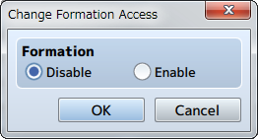

**Function**

Controls whether or not a player can change the formation of his or her party members. These settings will be left unchanged until changed using this event command again.

**Settings**

**Formation**

Set this to [Disable] to prevent the player from changing the party, and [Enable] to allow the player to change the party.

**Change Window Color**

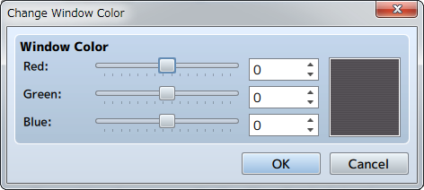

**Function**

Changes the window color settings. These settings will be left unchanged until changed using this event command again.

**Settings**

**Window Color**

Specifies the color after it is changed based on each of the [Red], [Green] and [Blue] component values (-255 to 255). The specified color can be checked in the preview area on the right.

**Change Actor Images**

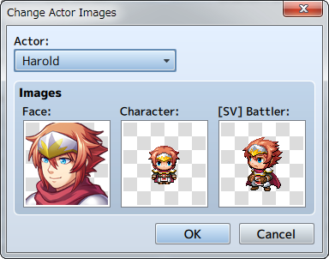

**Function**

Changes the image of an actor. These settings will be left unchanged until changed using this event command again.

**Settings**

**Actor**

Select the target actor.

**Images**

You can set images for the [Face], [Character], and [ [SV] Battler] in the window that opens when you double-click their images. Setting this to [(None)] will have an image not be displayed.

**Change Vehicle Image**

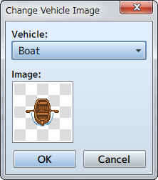

**Function**

Changes the image for vehicles. These settings will be left unchanged until changed using this event command again.

**Settings**

**Vehicle**

Specify the target vehicle.

**Image**

Double-click the image to specify the image that will display after the change. Setting this to [(None)] will have an image not be displayed.

Map

**Change Map Name Display**

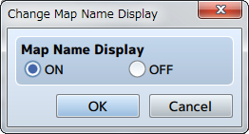

**Function**

Controls whether or not the name of a map will be displayed when moving to a different map.

**Settings**

**Map Name Display**

Set to [ON] to display the name, set it to [OFF] to hide the name.

**Change Tileset**

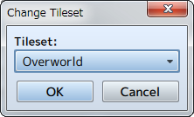

**Function**

Changes the settings of the map's tileset. The tileset that can be changed is limited to the map where the event was placed.

**Settings**

**Tileset**

Specify the tileset after changing it.

**Change Battle Back**

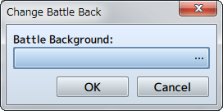

**Function**

Changes the settings for the map's battle back. The battle back that can be changed is limited to the map where the event was placed.

**Settings**

**Battle Background**

You can set the left and right images in the window that appears when you click the [...]. The specified image can be checked in the preview area on the right.

**Remarks**

* If this event is run during a battle event, the background will change from the next battle.

**Change Parallax**

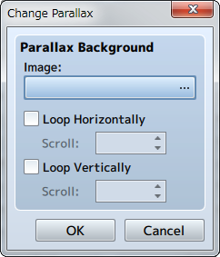

**Function**

Changes the settings for the map's parallax. The changing the parallax is limited to the map where the event was placed.

**Settings**

**Images**

Specify the image after it is changed.

**Loop Horizontally**

When enabled, the image will loop horizontally. Specify the speed (-32 to 32/0 to stop) in the [Scroll] section to auto-scroll the map.

**Loop Vertically**

When enabled, the image will loop vertically. Specify the speed (-32 to 32/0 to stop) in the [Scroll] section to auto-scroll the map.

**Get Location Info**

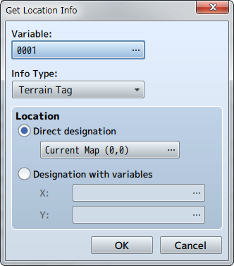

**Function**

References the value at the specified location on the map and stores it in a variable. Variables that can be referenced are limited to the map where the event was placed.

**Settings**

**Variable**

Specify the variable to store the acquired value.

**Info Type**

Specify the type of information that is acquired.

**Location**

Specifies the location of where to acquire the value. Select [Direct designation] to specify a specific location, and select the location in the window that opens when you press [...]. To specify the location using a map ID and coordinates, select [Designation with variables], and specify the variables for [X] and [Y].

Battle

**Change Enemy HP**

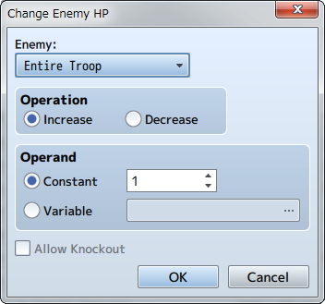

**Function**

Changes the HP of enemies.

**Settings**

**Enemy**

Specify the target enemy. Setting this to [Entire Troop] will target all enemies.

**Operation**

Select either [Increase] or [Decrease].

**Operand**

Specify the amount by which to raise or lower the HP. Select [Constant] to set this to a fixed value and enter the value. Choose [Variable] to set the amount using a variable, and specify the variable to reference.

**Allow Knockout**

When enabled, the enemy will be knocked out when its HP reaches 0. HP will remain at 1 even if the enemy's HP falls below 0 when disabled.

**Remarks**

* This can be used only in battle events.

**Change Enemy MP**

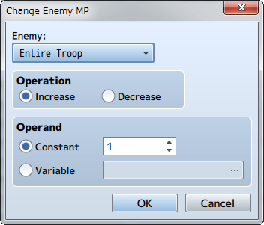

**Function**

Changes the MP of enemies.

**Settings**

**Enemy**

Specify the target enemy. Setting this to [Entire Troop] will target all enemies currently in battle.

**Operation**

Select either [Increase] or [Decrease].

**Operand**

Specify the amount by which to raise or lower the MP. Select [Constant] to set this to a fixed value and enter the value. Choose [Variable] to set the amount using a variable, and specify the variable to reference.

**Remarks**

* This can be used only in battle events.

**Change Enemy TP**

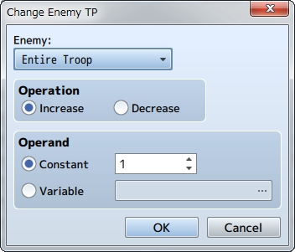

**Function**

Changes the TP of enemies.

**Settings**

**Enemy**

Specify the target enemy. Setting this to [Entire Troop] will target all enemies currently in battle.

**Operation**

Select either [Increase] or [Decrease].

**Operand**

Specify the amount by which to raise or lower the TP. Select [Constant] to set this to a fixed value and enter the value. Choose [Variable] to set the amount using a variable, and specify the variable to reference.

**Remarks**

* This can be used only in battle events.

**Change Enemy State**

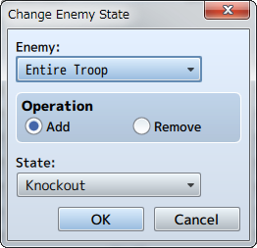

**Function**

Changes the state of enemies.

**Settings**

**Enemy**

Specifies the target enemy. Setting this to [Entire Troop] will target all enemies currently in battle.

**Operation**

Select either [Add] or [Remove].

**State**

Specifies the type of state to add or remove.

**Remarks**

* This can be used only in battle events.

**Enemy Recover All**

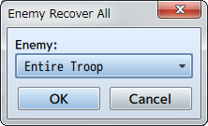

**Function**

Fully recovers the HP and MP of the enemy, and removes all states.

**Settings**

**Enemy**

Specifies the target enemy. Setting this to [Entire Troop] will target all enemies currently in battle.

**Remarks**

* This can be used only in battle events.

**Enemy Appear**

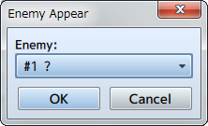

**Function**

Causes an enemy to appear which was had the [Appear Halfway] option set in the Troop section.

**Settings**

**Enemy**

Specifies the target enemy.

**Remarks**

* This can be used only in battle events.

**Enemy Transform**

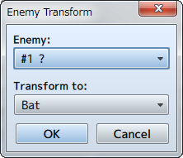

**Function**

Transforms an enemy currently in battle to a different enemy. The HP and MP from the enemy prior to transformation will be carried over to the new enemy.

**Settings**

**Enemy**

Specify the enemy to transform.

**Transform to**

Specify what the enemy will be after transforming.

**Remarks**

* This can be used only in battle events.

**Show Battle Animation**

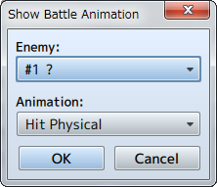

**Function**

Displays an animation using the enemy as the target.

**Settings**

**Enemy**

Specify the target enemy.

**Animation**

Specify the animation to display.

**Remarks**

* This can be used only in battle events.

**Force Action**

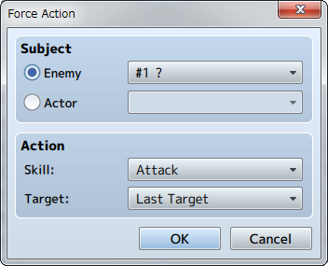

**Function**

Forces the enemy/actor to use the specified skill.

**Settings**

**Subject**

Specify the target enemy/actor.

**Action**

The skill that they enemy or actor will be forced to use is specified in [Skill]. Targets of the skill will be selected from the [Last Target] (the same target of the performer immediately before), [Random] (selected at random), [Index X] (X can be 1 through 8/refer to remarks for more information).

**Remarks**

* This can be used only in battle events.

**Abort Battle**

**Function**

Forces the battle to end and the game to return to the map. There are no parameters to set.

**Remarks**

* This can be used only in battle events.

Advanced

**Script**

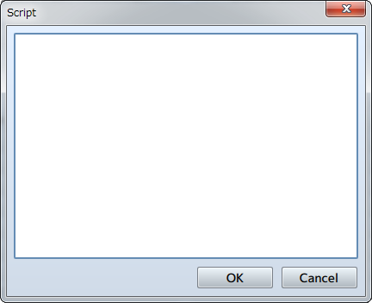

**Function**

Evaluates text as JavaScript.

**Settings**

**Script**

Enter the JavaScript to be evaluated.

**Plugin Command**

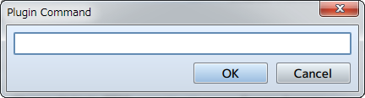

**Function**

Sends a command to a plugin.

**Settings**

**Plugin Command**

Input the command to send to the plugin.